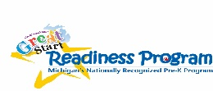
What NMCAA Child and Family Development Programs
are Doing to Keep your Family Safe
NMCAA is committed to protecting the health and safety of our children, families, and community. We appreciate your cooperation in implementing the protocol described below.
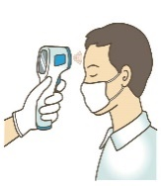
Upon arrival, your child’s temperature will be taken. Families will be asked if their child is in quarantine or has other signs of illness described in the sick policy. You will also be asked if your child has felt unwell in the last 24 hours (a fever of 100.4 degrees or above or signs of fever, sore throat, new uncontrolled cough (for children with asthma, a change from their baseline breathing), diarrhea, vomiting, stomach ache, new onset of severe headache, especially with fever. Contact your child’s primary care physician/medical provider and/or local health department for further guidance if the has been a close contact or feels unwell.
Staff will sign children/families in and out while entering and exiting the building. Physical distancing will be encouraged. All adults are required to wear masks while in the building. Non-essential visitors, volunteers, and guests will be limited in classroom activities at this time. Essential visitors will be required to clear a health screening which includes a temperature and symptom check.
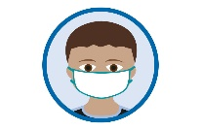
All individuals 2 years of age and older, regardless of vaccination status, are required to wear a mask indoors when Head Start services are provided, on all buses, and outdoors (for those who are not fully vaccinated). Exceptions include: children and adults when they are eating or drinking, children when they are napping, individuals who cannot safely wear a mask because of a disability as defined by the Americans with Disabilities Act, or when a child’s health care provider advises an alternative face covering to accommodate the child’s special health care needs. Programs will have masks available.
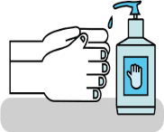
Each classroom and bus (if applicable) will have hand sanitizer available. Hand sanitizer does not replace hand washing, and the program will follow its hand washing procedure. Children will cover all surface of their hands with hand sanitizer, rubbing them together until they feel dry. Children should not bring hand sanitizer from home.
We will be providing family-style meals where children serve themselves and engage in conversations with their peers. Children will be spaced as far apart as possible. Children will wash their hands prior to and immediately after eating.
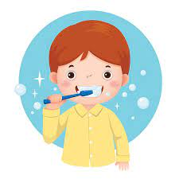
NMCAA promotes effective oral health hygiene by providing the opportunity for children to brush teeth once a day. Staff helping children with brushing will wear a mask and gloves for additional protection. The toothbrushing area will be cleaned and sanitized.
All children will have a nap/rest time in our full day classrooms. To reduce potential for viral spread, only bedding will be used that can be washed. When possible, children will be placed head-to-toe and physically distanced. Children will use the same cot and bedding each day. Bedding will be washed weekly or as needed. Blankets from home are not permitted.
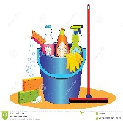
Cleaning/disinfecting of high-touched surfaces will occur daily (sinks, toilets, light switches, doorknobs, counter and table tops, chairs). Outdoor spaces will be cleaned according to the normal routine. Staff will use CDC-recommended disinfectants such as EPA-registered household disinfectants, diluted bleach solutions and alcohol solutions with at least 60% alcohol. Staff will follow the Routine Cleaning Guidance posted in the classroom.
A family health screening will be completed prior to the home visit. Masks should be worn by all individuals 2 years of age and older. It is requested that the number of individuals taking part in home visits be limited.
If a child, staff member, family member or visitor to our program shows COVID-19 symptoms or test positive for the virus, we will contact our local health department and licensing consultant. We will also communicate with the families as directed, regarding close contact quarentines and program closures, while respecting the privacy of the individual and not share health information of a specific person.
This information is subject to change as the situation evolves or as local, state, and federal orders related to COVID-19 are issued or amended. Staff will follow the NMCAA COVID-19 response and preparedness plan.
12/1/21 P:\Head Start Files\ADMIN\Procedure Manual\ Health\ What NMCAA Child and Family Development Programs are Doing to Keep your Family Safe

