Wait List Letter Guidance
Policy: Families that are still on the waitlist for Head Start and GSRP should receive a wait list letter in the mail prior to September 1 so families can make different arrangements if needed.

Families are encouraged to contact the Family Engagement Specialist to inquire about their placement on the waiting list. Families should know that throughout the school year, FES’ will include the families in Family Engagement Activities and newsletter mailings, to be updated on any resources and activities happening in the area.

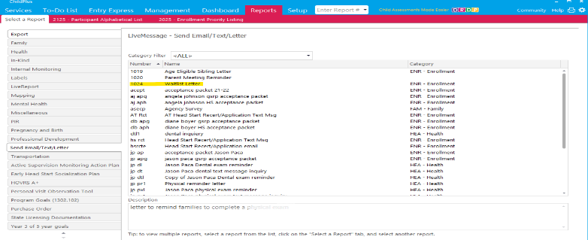
Procedure:
- Staff will use ChildPlus LiveMessage to send a wait list letter. Click on number 1024 Wait List Letter.

- Use Advanced Setup to send letters to multiple sites at one time. Be sure to use GSRP Pre-Kindergarten 22-23 and Head Start 22-23.
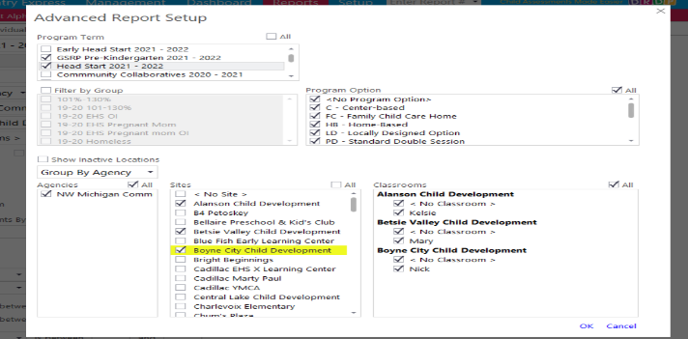

- Click ok. This will bring you to back to the original screen. You will want to click waitlisted and drop/wait. Click then on the Individual Tab.

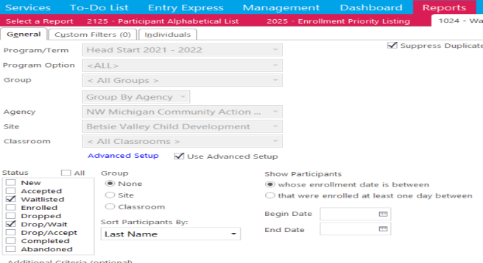

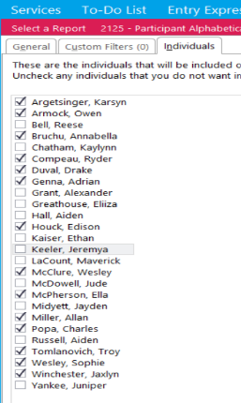
- Under the individual tab you can select the children that are on the current waitlist with a completed application. Returning children without a completed application may show up on the list so it is important to have your 2025 wait list to compare to.

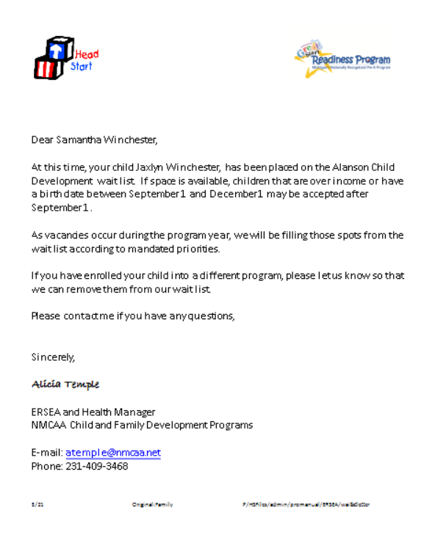
- Click Preview. All your letters will come up, you can now print them off. Each letter will have the parents name, child’s name and the classroom their child is on the wait list for.

