PIR Transportation only applies to Head Start and Head Start blended children. It does not apply to 100% GSRP.
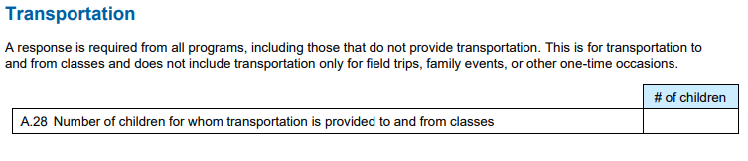
PIR Question A. 28 Transportation – Steps to add or update child transportation information in ChildPlus. To be updated in November, February and April.
Select a child from your participant list or from Report 2125. (Children’s names are in blue. This is a hyperlink to the child’s record)
Once you have a child selected, choose PIR from the menu bar.
Scroll to bottom of page until you see Transportation. You must edit/change to yes if transportation to and from school is provided. ChildPlus defaults all applicants to No.
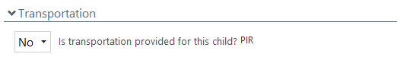

Entering the type of Transportation provided.
DMT will enter ‘Yes’ for “Self (transport)” for all Head Start applicants.
Site Supervisors will need to edit/update transportation option as applicable.
To edit the transportation option select a child from your participant list or from Report 2125. (Children’s names are in blue. This is a hyperlink to the child’s record)
Select Application
Scroll to the Agency-Specific Information section
Scroll down until you see these 4 boxes/choices. Choose the appropriate form of transportation getting the child to and from classes. These are pull down menus with a simple Y or N. Only choose 1. Add any notes that apply to transportation.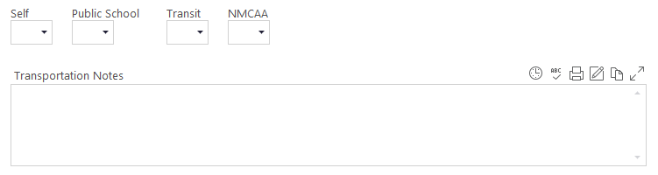
To assist you with child names you can run Report 2125 Participant Alphabetical List.
A sample of report 2125 set up is below.
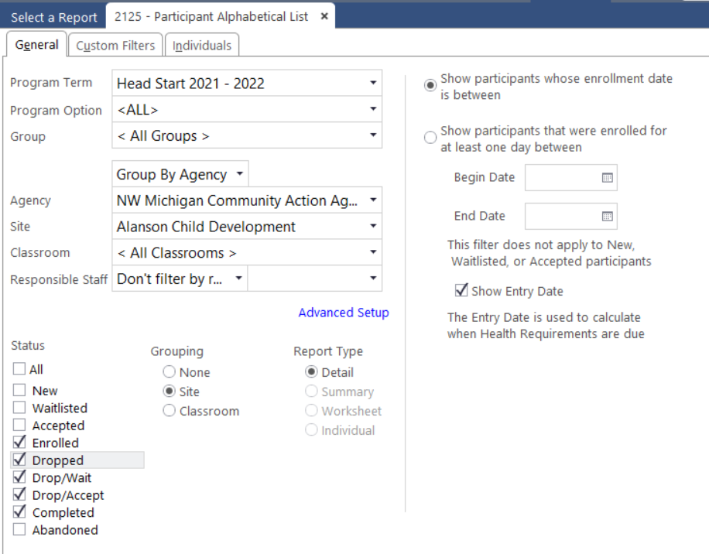
Choose Preview instead of print. This will allow you to hyperlink to each child’s record.

