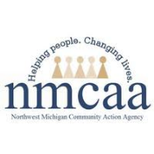

School Readiness Begins with Health

Physical Health
Children who access ongoing health care have better attendance and are more engaged in learning. Consistent attendance helps children prepare for school. Routines such as handwashing and wearing helmets help children stay healthy and avoid injuries.
Oral Health: Children with healthy teeth are better able to eat, speak, and focus on learning. Daily oral health hygiene and ongoing care from oral health professionals help make sure that children have healthy teeth.
Nutrition: Good nutrition is essential for children's brain development. Children who have access to nutritious food have energy to learn. Providing healthy snacks and meals helps children's bodies grow, giving them what they need to talk, play, and learn together.
Physical Activity and Motor Development: Staying active benefits young children's physical and cognitive development. Activities that get children moving build motor skills that are useful to reading, writing, and math skills.
Sleep and Rest: When children get enough sleep, they can pay attention, remember what they learn, and manage their feelings. When caregivers schedule times for a nap, rest or quiet activities, children can focus on learning.
Perceptual Development: When children use their senses to explore, it helps them learn about the world around them. A child's ability to see and hear affects their reading, writing, and speech and language skills. Sensory screening helps identify children who may need vision or hearing support.

Mental Health
Beginning at birth, children need positive relationships with the adults who care for them. When children learn to recognize and share their feelings with trusted adults, they feel good about themselves. These relationships help them develop the confidence to learn new skills. Children also learn how to manage their feelings, thoughts, and behavior.
Nurturing and Responsive Relationships: Early relationships shape children's learning and development. Children thrive when adults support their strengths and needs. Responsive adults help children feel safe and valued and learn how to get along well with others.
Self-Regulation: Children who can manage their feelings can learn and play with peers. They are better able to plan, monitor and control their behavior. They can also adjust to changes in schedules and routines.
Prosocial Behavior: Children who get along with adults learn to work together and follow rules. They can also show concern for, and share, take turns and compromise with other children.
Play: When children play, they use their imagination and creativity. They also solve problems and learn to interact with others; skills that help them grow in all developmental areas.

5/23 Distribution: Families receive in Acceptance Packet or EHS Enrollment EHS-HS Teams\Admin\Acceptance 23-24\School Readiness Begins with Health
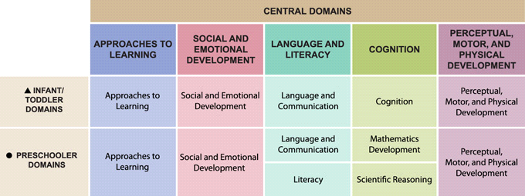

Dental Exam /

Oral Health Screening

Well

Child

Exam

/
Physical

Exam

Lead Screening

Vision Screening

Hearing

Screening

Hemoglobin Screening

Early Learning Outcome Framework

connects to all of your child’s Health Screening
s
.

5/23 Distribution: Families receive in HS Acceptance Packet or at EHS enrollment EHS-HS Teams\Admin\Acceptance 23-24\School Readiness Begins with Health

