Report 4110 Family Service History
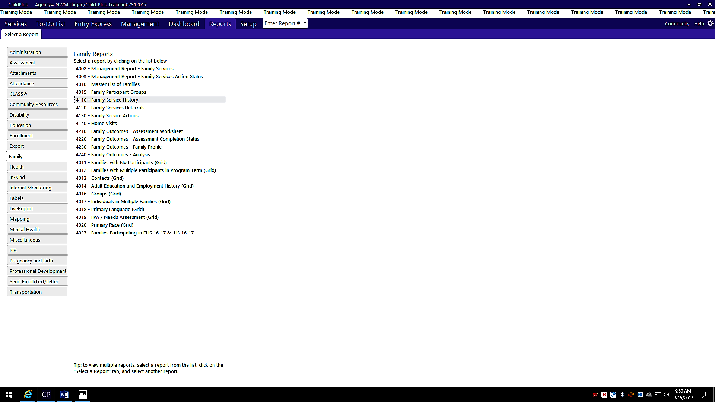
Choose the Report tab and then Family from the column on the left side of the screen. From the list of Family Reports choose 4110 Family Service History. This report will give you a profile of direct services, referrals and Family Partnership Agreements for the year (or for a defined time frame using the initial services date filter) for all the families you serve.

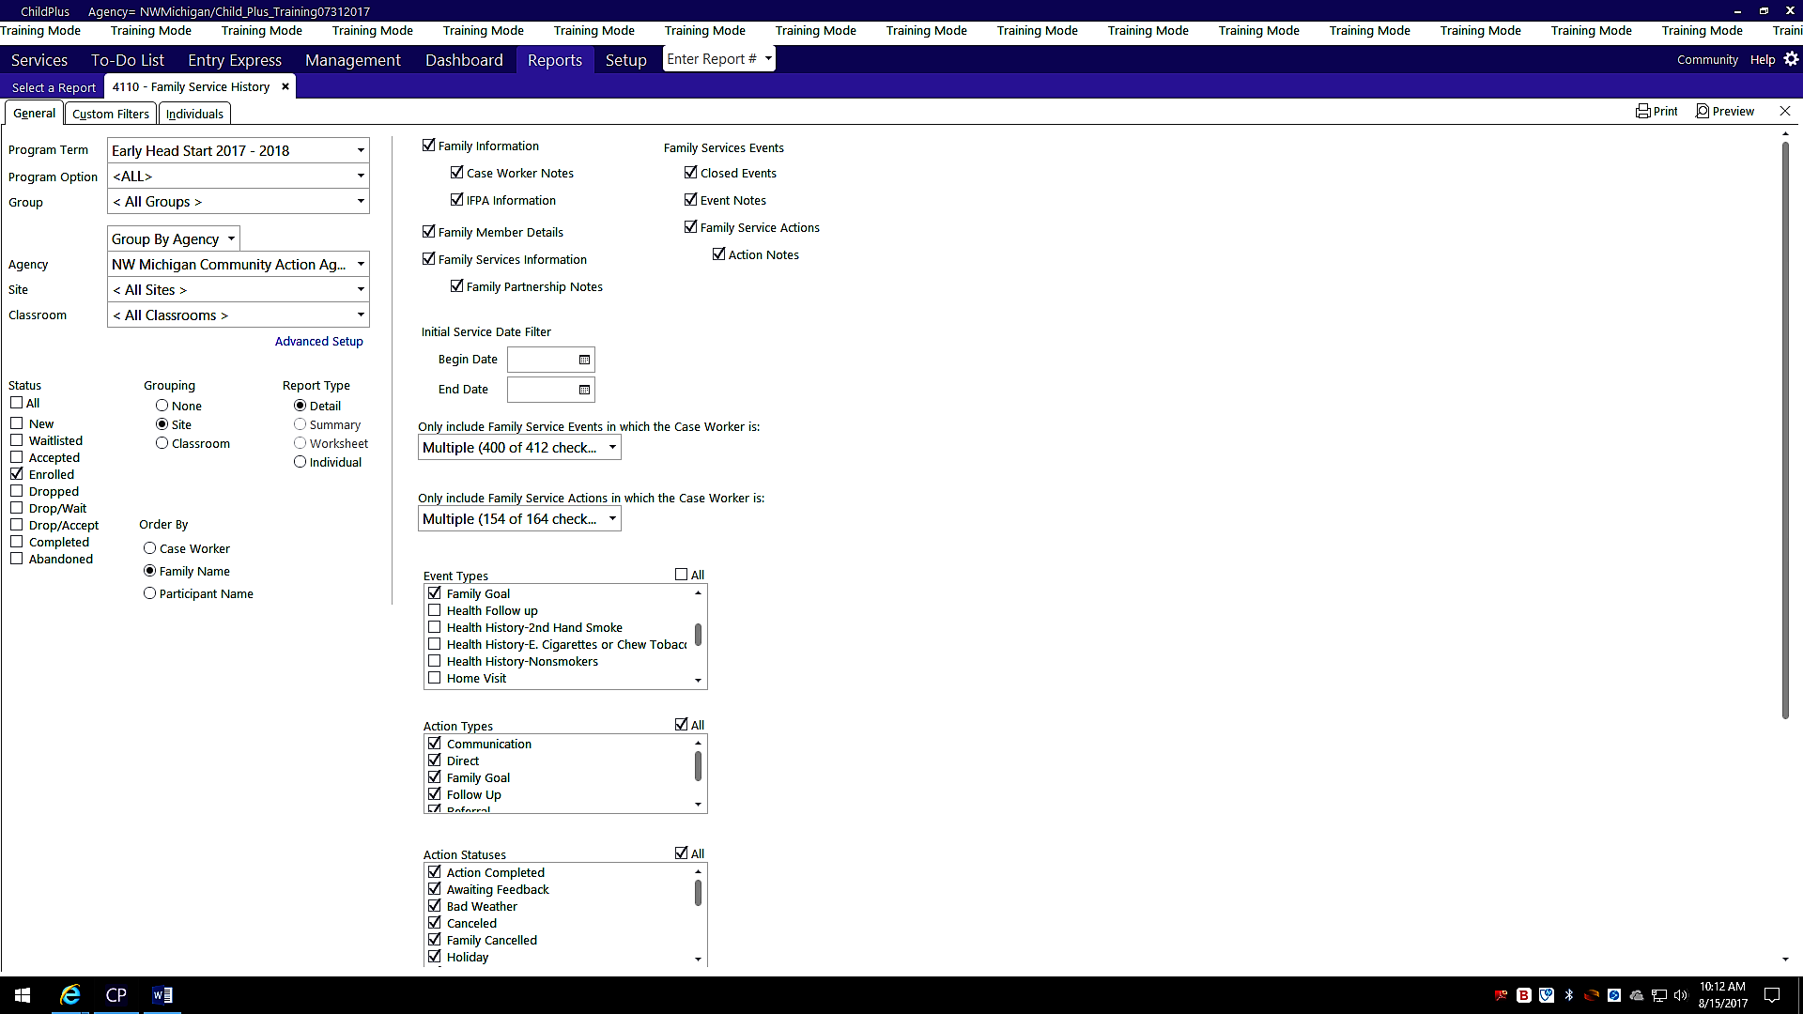
Select the Program Term, Site and Classroom. Status= Enrolled Children
Event Type= Choose either Need Identified, Family Goal or both. Choose ‘All’ for Action Types and Action Status.

