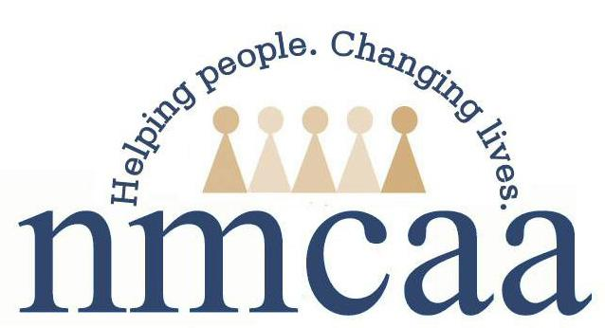
Release of Information to and ID Verification of Child Protection Personnel

Policy:
Staff will ensure that confidentiality is maintained at all times as it relates to program children, their records and personal information, and their families. Staff will verify the identity of all child protection personnel prior to the disclosure of any information as it relates to program children and/or their families. Staff will only provide the relevant information requested by child protection personnel.

Procedure(s):
Staff must request verifying information prior to communicating with child protection personnel; any and all communications must be documented accordingly. Staff must adhere to the following guidelines to ensure that these procedures are met:

When receiving a call from an unknown Child Protective Services worker/Police Officer/Foster Care Case manager, respectfully and quickly verify that the worker is legitimate by doing the following:

- Ask the worker to text, email or fax his/her identification badge to the center; the worker can stay on the phone while this process is taking place;
OR
- Ask the worker to text, email or fax a copy of his/her request on letterhead; the worker can then be called back to answer his/her questions;
OR
- Ask for the phone number of the worker’s supervisor; contact the supervisor to confirm that the caller is certified personnel at that agency.

When a Child Protective Services worker/Police Officer/Foster Care Case manager comes to the classroom to speak with staff or the child, verify the child’s presence, or request other information, verify his/her identification by doing the following:

- Ask the worker for his/her identification badge; make a copy for your records.

Communication with Child Protection Personnel
- When a request for information is solicited over the phone or in person, staff will only provide details specific to the request; staff will refrain from providing unsolicited information and/or providing their personal views and/or opinions.
- Head Start will document any visit or phone call using the Head Start Contacts and Social Service Tracking form.
- Collaborative Center staff will notify their CCSC within 12 hours of any visit or phone call to or from CPS personnel regarding an EHS/HS enrolled child.
- CCSC and EHS staff will document any phone call directly into Child Plus as a Need Identified in the Family Services tab for that child.

Per Child Protective Services’ request, do not contact the family when the following takes place:

- When reporting suspected child abuse or neglect;
OR
- When Child Protective Services calls or visits the center seeking information about a child or family.

References: Licensing R 400.8125; HSPPS 1303.22 (c)(5)(7)(8); 1302.47 (b)(5)(iv); 1302.90(c)(iv); 1303.20; 1303.24(b); GSRP-Sensitive Interviewing

3/23 EHS-HS Teams\Admin\Procedure Manual\Licensing\Release of Information and ID Verification of Child Protective Personnel

