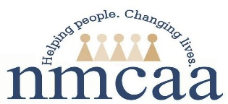
PROCEDURE FOR ENROLLING 101-130% AS INCOME ELIGIBILE
Early Head Start/Early Head Start Child Care
Head Start/Head Start Child Care

- Management Staff (PSC; CC Support Coordinator; Education Coach) will contact Michelle Karns (DMT) to ensure there are no income eligible children on the individual site/ center waitlist.

- If there are income eligible children on the wait list, one of these children would need to be enrolled, unless there are family circumstances that prevent the income eligible child from enrolling.

- If there are no income eligible children on the wait list, authorization will be given to enroll the 101-130% child as income eligible. A Change of Status will be completed, checking the 101-130% box.

- If there are eligible children on the wait list that cannot be added at this time due to certain circumstances Michelle needs to be made aware of this to update the current wait list. Once Michelle makes these changes on the wait list an updated wait list needs to be printed. (Examples of changes could be that EHS is in the home already and does not have space for another dual enrolled family.) If child has moved please do a Change of Status.

- A copy of the current/updated wait list will be printed that day and attached to the Change of Status to be sent to Michelle DMT for enrollment.

- The Change of Status will (without the wait list attached) be placed in the child’s file.

- Staff will make an additional copy of the wait list and Change of Status to be placed in a file labeled 101-130% income eligible. This file must be kept on site where the child is enrolled.
6/17(REV 10-27-16) p: hs/admin/ pro manual/ERSEA/ Procedure 101-130%

