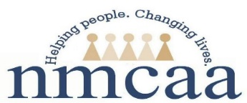

Procedure for DHHS Licensing Letters

Correspondence from DHHS is sent to the 3 Mile address; mail is picked up daily and appropriate mail is brought to the Administrative Offices.
Normally, DHHS letters are emailed electronically to the site supervisor. Site supervisors forward a copy of the letter to the classroom with a note to print off and place in their licensing notebook. Supervisors also forward the letter to Kaylee Lovejoy (klovejoy@nmcaa.net). Kaylee prints off the letter and it is sent to the Executive Director to await initialing. Once it is initialed, it is filed in the cabinet at Logan’s Annex. It is also uploaded in Sharepoint.
- If the letter requests a Corrective Action Plan, Site Supervisors will send a copy of the CAP to Program Support, the Program Manager, and the classroom for the Licensing Notebook.

- The DHHS CAP acceptance letter will be copied and distributed as above.

- All DHHS licensing correspondence will be copied and distributed as above. Occasionally a letter specifies it is not to be placed in the licensing notebook. In this case Program Support will send it with a note to that effect.

- Original License will be copied- Original will go in the classroom mailbox to be mailed-the copy will be placed in the program support licensing files. It will also be uploaded to Sharepoint, and uploaded onto ChildPlus in the State Documentation tab.
Further, Program Support will upload all letters from DHHS related to licensing into ChildPlus Report 1300. This information can be viewed in Report 1014. A report detailing violations can be found on Microsoft Teams under CFD Data –- HS-GSRP Compliance – Licensing Violations – 2022-2023

