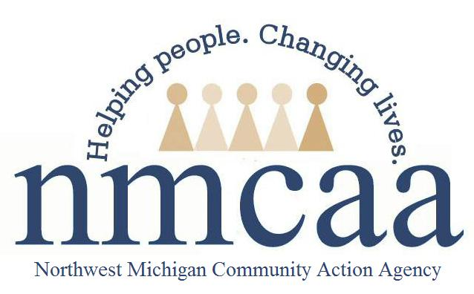

NMCAA Email Encryption Notice

I understand it is my responsibility as an employee of NMCAA to ensure all sensitive/confidential information is safeguarded. As a part of this, I will ensure that all electronic communication containing sensitive/confidential information will be encrypted. It is my responsibility to ensure all email sent to an outside individual or entity containing sensitive/confidential information is encrypted.

Examples of information that should be encrypted:
- Privacy – Messages subject to encryption contain the following data types: credit card numbers and expiration date, date of birth, Social Security number, driver's license number, street address, or phone number.
- HIPAA – Messages will be subject to encryption if they contain any information protected under HIPAA privacy regulations.

If you need to encrypt an outgoing message, put -secure- in the subject line or body of the email. Secure must be typed in bold font with a hyphen on either side of the word secure: -secure-

Signature: ______________________________________________ Date: ___________________

4/2021 P:/Head Start/Admin/Procedures Manual/Technology/Encryption Notice

