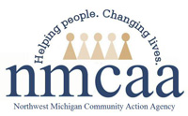

NMCAA - Civil Rights Complaint Procedure

What to do if you believe you have been treated unfairly is included on all materials relating to the CACFP that are available to the public. This includes the NMCAA website, parent handbook and any other applicable materials such as the CACFP enrollment form.
Individuals with complaints or grievances based on any of the conditions listed in the Non-Discrimination Statement will be informed of their right to complain and encouraged to look at the Justice for All poster for instructions on how to do so. Individuals may also contact Shannon Phelps, Abria Morrow or Kim Aultman at NMCAA to voice their concerns regarding the food program or other matters. NMCAA staff will notify Shannon Phelps, Abria Morrow or Kim Aultman when they are aware that a complaint or grievance has been made.

Reference: United States Department of Agriculture- And Justice For All poster

7/2022 P\Head Start\USDA\all 2022-2023\Civil Rights\Civil Rights Complaint Procedure

