Procedures for Data Entry Child Plus
and Entry Express
HSPPS 1302.52 (a-d) Family partnership services

Family Services, Events Tab
- Click Services on the far left; select the child from the list of participants below or search for the child by name or birthdate using the search bar.
- Click Family Services (third from the left)
- Click Events on the left

- Shortcut for designating Case Worker (Unless the family is dual-enrolled, in which the Case worker should be EHS CFS)
  - Click Family Services Information tab
  - Go to the drop-down list of names. Begin typing Case Worker last name and click enter when correct name appears OR click scroll down arrow for list of names and click enter.
  - Click “Save” when finished . Thereafter, the correct name will automatically populate each time you “Add Event & ADD Action.”
- Family Partnership Agreement –
  - Still in the Family Services Information tab, scroll down to Family Partnership Agreement.
  - Click Yes
  - add effective dates. Start date - date of Orientation, this is when families signed the Head Start Orientation and Family Partnership Agreement
  - Effective until AUG 31! (Always update for the current year)
  - Click “Save” when finished .
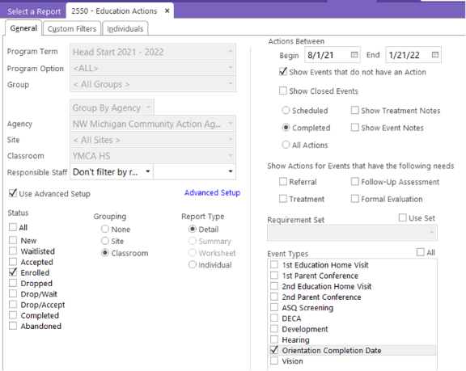

2b. To find date of orientation:
Orientation Date Report in CP 2550

  - You MUST fill in both the Actions Between Begin and End date boxes or it will run incorrectly.

Dual Enrolled families: Enrolled in EHS and HS, EHS will initiate/complete the Family Partnership Agreement, Family Needs Assessment and Family Outcomes Tool in Child Plus & provide copies to Head Start Teacher for supporting the family & for the child file.

Adding an Event:
You will “Add Event” in the Family Services section of Child Plus for the following:

1. Home Visits – Documenting home visits (For FES)
2. FES Need Identified – The family has a need requiring support through direct service or referral.
- Direct Services
- Referrals (Includes CPS referrals made by staff)
- Communication which needs documenting such as:
  - CPS involvement (Staff made a CPS referral; OR staff did not make a referral, but CPS called and/or observed at school for information or to give information).
  - Chronic absenteeism (Follow up within Attendance Tab; See ChildPlus Direct Entry Attendance Follow Up - FES Instructions)
3. Family Partnership Agreement Goal Process- The family is establishing FPA goals.

4. Parent Engagement- The parent/guardian has attended an event at which a segment of YJT was presented.
- Parent Meeting
- Parent Advisory
- Parent Workshop
- Family Engagement Event

5. Entry Express Directions are near the end of this document- How to enter a flier or resource shared with multiple families at one time or Parent Engagement event.

1a. Home visit Complete (FES)
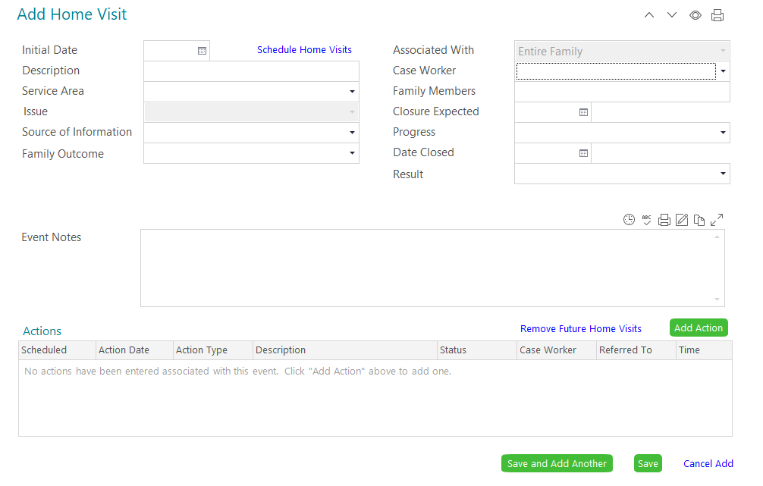
Click Add Event: Home Visit
- Initial Date: when home visit took place
- Description: Enter Home Visit Completed
- Service Area: Social Service
- Issue: Leave blank
- Source of Information: Leave blank
- Family Outcome: These are the areas of the HS Parent Family and Community Engagement Framework. Choose only 1 that applies. [1302.52 (b)]
- Associated With: This will be auto filled
- Case Worker: Drop down list of names* Begin typing your last name & click when your name appears.
- Family Members: Leave blank
- Closure Expected: Leave blank
- Progress: Click Completed (Date completed)
- Date Closed: Date Completed
- Result: leave blank
Action Notes: Use time stamp each time an entry is made. This area can be used to provide additional detail about identified need. Click “Save” when finished

1b. Home Visit Missed (HVM)
Chronic cancelling or nobody home. Takes place after 2nd HV missed or Cancelled.
Add Event: Home Visit
- Initial Date: When home visit was scheduled.
- Description: Enter Home Visit Missed OR HVM
- Service Area: Social Services
- Issue: Leave blank
- Source of Information: Leave blank
- Family Outcome: These are the areas of the HS Parent Family and Community Engagement Framework. Choose only 1 that applies. [1302.52 (b)]
- Associated With: Leave blank
- Case Worker: Drop down list of names* Begin typing your last name & click when your name appears.
- Family Members: Leave blank
- Closure Expected: Leave blank
- Progress: Click Cancelled
- Date Closed: Date Cancelled
- Result: leave blank
Action Notes: Use time stamp each time an entry is made. Use this to provide additional details about HVM. Ex. - Original dates should be identified for when hv was scheduled with description; mom called to cancel on ______ (date) because ____________.
Click “Save” when finished

2. FES Need Identified
(Family has a Need Identified that is requiring support through Direct Service OR Referral).
The first time you enter FES Need Identified:
1. Add Event first (This is where you will record the FES Need Identified)
2. ADD Action second (This is where you will record all ACTIONS completed while working on FES Need Identified. Phone calls, Referrals, Follow ups, etc…) see yellow arrow

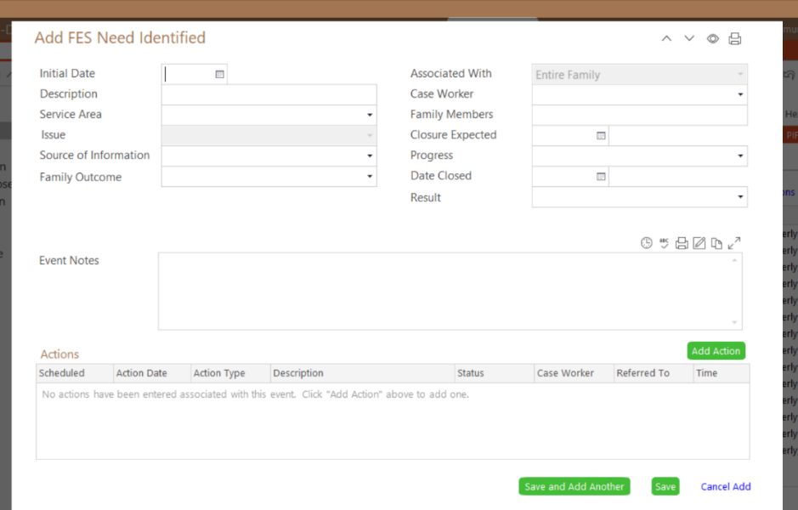

Types of FES Needs Identified:
A. Direct Service:
Staff provided a Direct Service (To meet FES Need Identified; Examples: a requested handout or children’s social story or social emotional book related to a topic; A one-to-one “mini training,” which needs to be added to PIR fields of Need Identified & Parenting Education) Other examples - budgeting, cooking, positive guidance, child development, etc.; OR parenting support from (Your Journey Together parenting curriculum), Conscious Discipline or parenting guidance that is “individualized” for situation (not the same handout provided to all families).
- Click Add Event: FES Need Identified
- Initial Date: Date of FES Need Identified
- Description: Enter description of need.
- Service Area: Social Services
- Issue: Choose appropriate within scroll down menu
- Source of Information: Choose appropriate within scroll down menu
- Family Outcome: These are the areas of the HS Parent Family and Community Engagement Framework. Choose only 1 that applies. [1302.52 (b)]
- Associated With: This will be auto filled
- Case Worker: Drop down list of names* Begin typing your last name & click when your name
- Progress: In Progress, Cancelled or Completed (Date completed)
  - Cancelled is only by the family if they no longer want the help with the FES Need Identified
  - Complete is when the FES Need Identified is Met
  - In Progress (Staff will progressively follow up on FES Need Identified with the family)
  - No Response after multiple staff attempts to support FES Need Identified
- Date Closed: Date Completed
- Closure Expected: Leave blank
- Family Members: Leave blank
- Result: Leave blank
Action Notes: Use time stamp each time an entry is made. This area can be used to provide additional detail about identified need. Click “Save” when finished

NEXT Click Add Action:
- Action Type: Scroll down arrow (Direct)
- Scheduled: Leave Blank
- Action Date: Date of Direct Service
- Type of Contact: Scroll down arrow (Choose type of contact that applies)
- Description: Describe the Direct Service
- Status: Scroll down arrow (Referral is Action Completed, Family Cancelled or Ongoing)
  - Action Completed is when referral service need is met. Mental Health Referrals are completed only when the first mental health session are completed
  - Family Cancelled is only when family no longer wants Referral OR family is ineligible OR service is no longer available
- Case Worker: Begin typing last name & click enter when correct name appears OR click drop down list
- Total Time: leave blank

Action Notes: Timestamp entries. Use this area as a running log to provide any additional details and/or ongoing information related to the status of a referral.

Click “Save” when finished

For accurate Reports & keeping PIR up to date, staff must do the following when providing a Direct Service (giving a “mini training”)
- Go to Family Services Information tab
- If Direct Service “mini training” is complete:
- Go to appropriate Services Received boxes & click yes

B. Referral:
A referral is being made to meet FES Need Identified
Click Add Event: FES Need Identified
- Click Add Event
- Initial Date: Date of FES Need Identified
- Description: Enter description of need.
- Service Area: Social Services
- Issue: Choose appropriate within scroll down menu
- Source of Information: Choose appropriate within scroll down menu
- Family Outcome: These are the areas of the HS Parent Family and Community Engagement Framework. Choose only 1 that applies. [1302.52 (b)]
- Associated With: This will be auto filled
- Case Worker: Drop down list of names* Begin typing your last name & click when your name appears.
- Family Members: Leave blank
- Closure Expected: Leave blank
- Progress: In Progress, Cancelled or Completed (Date completed)
  - Cancelled is only by the family if they no longer want the referrall
  - Complete is when FES Need Identified is Met
  - In Progress (Staff will progressively follow up on FES Need Identified with the family)
  - No Response after multiple staff attempts to support FES Need Identified
- Date Closed: Date Completed
- Result: leave blank
Action Notes: Use time stamp each time an entry is made. This area can be used to provide additional detail about identified need.

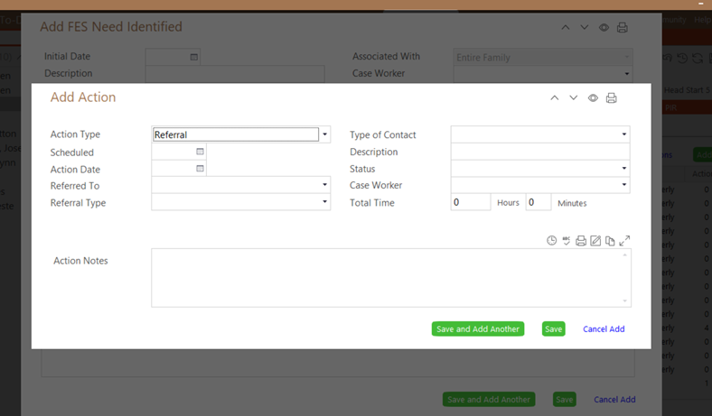
Click “Save” when finished
NEXT Click Add Action

- Action Type: Scroll down arrow (Referral)
- Scheduled: Leave Blank
- Action Date: Date of Referral
- Type of Contact: Scroll down arrow (Choose type of contact that applies)
- Description: Where the Referral is made to (Keep each referral as separate Add Actions; Ex – Heat Assistance to DHHS and NMCAA would be separate Add Actions)
- Status: Scroll down arrow (Referral is Action Completed, Family Cancelled or Ongoing)
  - Action Completed is when referral service need is met. Mental Health Referrals are completed only when the first mental health session is completed
  - Family Cancelled is only when family no longer wants Referral OR family is ineligible OR service is no longer available
- Case Worker: Begin typing last name & click enter when correct name appears OR click drop down list
- Total Time: leave blank

Action Notes: Timestamp entries. Use this area as a running log to provide any additional details and/or ongoing information related to the status of a referral.

Click “Save” when finished

Referral Follow Up
Same process for School Readiness Goal & Family Goal Follow Up
Staff must follow up on Referral within 30-45 days Immediate needs should be followed up asap

Go to original event entered & open
Click Add Action

- Action Type: Scroll down arrow (Follow Up)
- Scheduled: If you know date of appointment, you can enter it
- Action Date: Follow Up date
- Type of Contact: Scroll down arrow (Choose type of contact you had for Follow Up)
- Description: Describe the outcome of Follow Up
- Status: Scroll down arrow (Referral is Action Completed, Family Cancelled or Ongoing)
  - Action Completed is when referral service need is met. Mental Health Referrals are completed only when the mental health sessions are completed
  - Family Cancelled is only when family no longer wants Referral OR family is ineligible OR service is no longer available
  - Ongoing Is until there is an outcome of either Action Completed or Cancelled
- Case Worker: Begin typing last name & click enter when correct name appears OR click drop down list
- Total Time: leave blank
Action Notes: Timestamp entries. Use this area as a running log to provide any additional details and/or ongoing information related to the status of a referral. Click “Save” when finished

When Referral is Completed or Cancelled:
- Go to original Event entry and change from In Progress to Completed or Cancelled.
- Date Closed: Enter date Completed or Cancelled

For accurate Reports & keeping PIR up to date, staff must do the following when making Referrals:
- Go to Family Services Information tab
- If Referral is complete:
- Go to appropriate Services Received boxes & click yes

C. School Readiness Goal The family is establishing School Readiness Goals (Child Development). School Readiness Goal follow-up occurs at home visits, PTC, and if appropriate during phone or center contacts. Add Action. (See above Referral Follow Up instructions because it’s the same Add Action process.)
Referral or Direct Service may not apply to School Readiness Goal; If it does apply, then follow the Referral Add Action process.
- Click Add Event: School Readiness Goal
- Initial Date: Date of School Readiness Goal identified
- Description: Enter description of School Readiness Goal(s)
- Service Area: Social Services
- Issue: Child Development (Child goal)
- Source of Information: Choose appropriate within scroll down menu
- Family Outcome: These are the areas of the HS Parent Family and Community Engagement Framework. Choose only 1 that applies. [1302.52 (b)]
- Associated With: This will be auto filled
- Case Worker: Drop down list of names* Begin typing your last name & click when your name appears.
- Family Members: Leave blank
- Closure Expected: Leave blank
- Progress: In Progress, Cancelled or Completed (Date completed)
  - In Progress (Staff will progressively follow up on goal with the family)
  - Complete is when school readiness goal is complete
  - Cancelled is only by the family if they no longer want the goal
- Date Closed: Date when school readiness goal is accomplished or is cancelled
- Result: Leave blank

Action Notes: Timestamp entries. Use this area as a running log to provide any additional details and/or ongoing information related to the status of a referral. Click “Save” when finished

When School Readiness Goal is Completed or Cancelled:
- Go to original Event entry and change from In Progress to Completed or Cancelled.
- Date Closed: Enter date Completed or Cancelled

D. Communication (which needs documenting):
- CPS involvement (Staff made a CPS referral; OR Staff did not make a referral, but CPS called for information or to give information and/or observed at school).
  - Click Add Event
  - Initial Date: Date of Need Identified
  - Description: Enter description of communication topic
  - Service Area: Social Services
  - Issue: Child Abuse and Neglect
  - Source of Information: Choose appropriate from scroll down menu
  - Family Outcome: These are the areas of the HS Parent Family and Community Engagement Framework. Choose only 1 that applies. [1302.52 (b)]
  - Associated With: This will be auto filled
  - Case Worker: Drop down list of names* Begin typing your last name & click when your name appears.
  - Family Members: Leave blank
  - Closure Expected: Leave blank
  - Progress: In Progress, or Completed (Date completed); Mostly this will either be In Progress or Complete
    - In Progress if CPS referral is made (until case closed) then Complete.
    - Complete on date of action for all other CPS involvement
  - Date Closed: Date of communication or CPS called, or CPS observed
  - Result: Leave blank

Action Notes: Use time stamp each time an entry is made. This area can be used to provide additional detail about identified need. Click “Save” when finished

E. Chronic Absenteeism also needs documenting:
- Either select child from your Attendance Dashboard or via the Attendance tab
- Click on (Green) Add Follow Up
- Select Due Date
- Choose the kind of follow up:
  - Attendance Plan
  - Follow Up Required
  - Multiple Absences
  - Multiple Tardies
  - Percentage of Attendance
- Enter the responsible staff person’s name for the specified attendance follow up.
- Enter whether or not the follow up has been completed.
- Within the Notes section, tell the story of what happened.
  - An example for the Notes section would be to document that a home visit occurred and what was addressed.
  - Another example for the Notes section might be to include what a family shares regarding a barrier to attending regularly and any plans created to address the barrier. If follow up to the barrier is tracked in Family Services tab, note “See Family Services tab”

Save when finished
3. Family Partnership Process Goal. [1302.52(a)] This is where we show details about the Family Goal Actions, such as Direct Service or Referrals, related to the FPP Goal will be recorded in the “Add Action” section.
Family Goal
- Add Event first as Family Goal
- Initial Date: Date goal was set OR parent declined to set a goal.
- Description: Write description of goal
- Service Area: Social Service
- Issue: Drop down menu for appropriate choice
- Source of Information: Choose appropriate from scroll down menu
- Family Outcome: These are the areas of the HS Parent Family and Community Engagement Framework. Choose only 1 that applies. [1302.52 (b)]
- Associated With: This will be auto filled
- Case Worker: Begin typing your last name & click when name appears OR click drop down menu for names.
- Family Members: Leave blank
- Closure Expected: Aug 31 (with follow-up by end of school year)
- Progress: In Progress, Complete (Date completed) or Cancelled
  - In Progress (Staff will progressively follow up on goal with the family)
  - Complete is when family goal is complete
  - Cancelled is only by the family if they no longer want the goal
  - No Response after multiple staff attempts to support goal progress
- Date Closed: Date Completed or Cancelled
- Result: leave blank

Action Notes: Timestamp entries. Use this area as a running log to provide any additional details and/or ongoing information related to the status of a referral. Click “Save” when finished

When a Family Goal is Completed, Cancelled or No Response to repeated attempts to contact the family:
- Go to the original Event entry and change from In Progress to Completed, Cancelled or No Response.
- Date Closed: Enter date Completed, Cancelled or after multiple attempts with No Response at the end of the school year.

AFTER Family Needs Assessment is completed: Go to Family Services Information Tab:
For Accurate Reports & keeping PIR up to date, do the following direct entry:
Family Needs Assessment
- Once FNA is completed - Click yes for completed within the Family Services Tab
- Click the date
- Valid until – Aug 31
Family Needs Assessment Results
- Needs Services – Click yes if services needed are identified from completing the FNA
- Received Agency Social Services – Click yes if nmcaa services were received as a result of completing the FNA
- Additional Community Services Needed – Click yes if family/staff identify services needed as a result of completing the FNA
- Referred to Another Agency – Click yes if staff refers family to another agency for identified services needed as a result of completing the FNA
Family Partnership Process
- In Family Goal Setting Process - Click yes, if the relationship building process with the family has begun after a home visit, even if a goal is not yet set.
- Family Partnership Notes - Add if relevant

4. Parent Engagement- The parent/guardian has attended an event at which a segment of YJT was presented.
- Parent Meeting
- Parent Advisory
- Parent Workshop
- Family Engagement Event

- Click Add Event
- Initial Date: Date of Parent Engagement
- Description: Enter description of Parent Engagement
- Service Area: Social Services
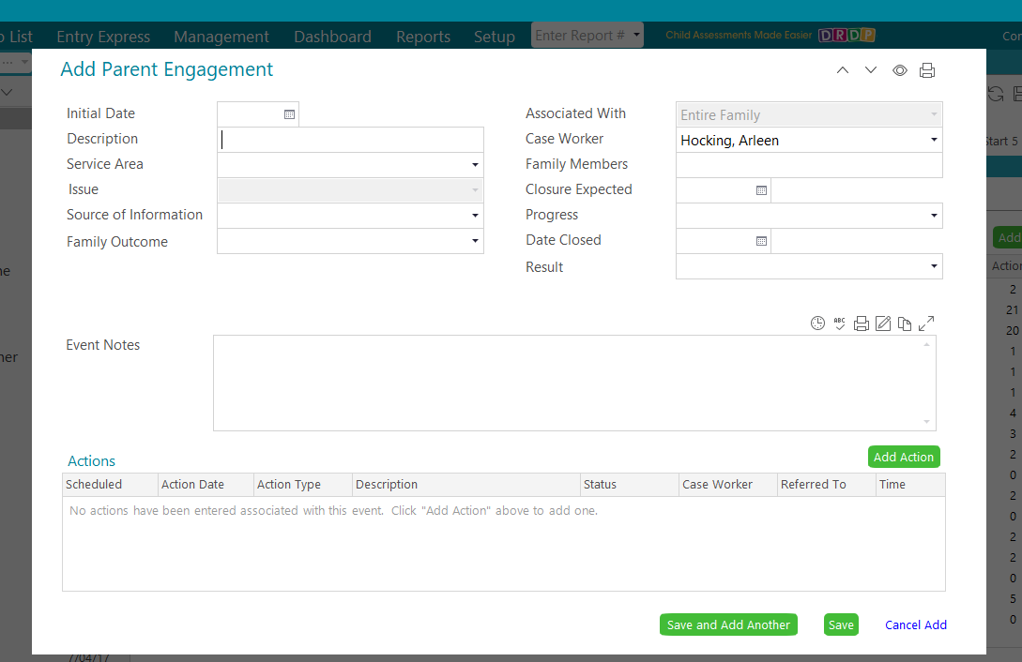
- Issue: Research-based parenting curriculum – Your Journey Together
- Source of Information: Choose appropriate within scroll down menu
- Family Outcome: These are the areas of the HS Parent Family and Community Engagement Framework. Choose only 1 that applies. [1302.52 (b)]
- Associated With: This will be auto filled
- Case Worker: Drop down list of names* Begin typing your last name & click when your name appears.
- Family Members: Leave blank
- Closure Expected: Leave blank
- Progress: In Progress or Complete
  - In Progress (if parent requests follow-up)
  - Complete (YJT completed at engagement Event)
- Date Closed: Date when YJT is accomplished
- Result: Leave blank

Action Notes: Timestamp entries. Use this area as a to record the YJT activity in fullness. (What activity was done, how it was completed, etc.…) Click “Save” when finished

5b. How to enter a Parent Meeting/Advisory, Parent Workshop or Engagement at which parents participated in YJT activity- Entry Express
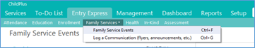
Go to Entry Express
Select: Family Services Event

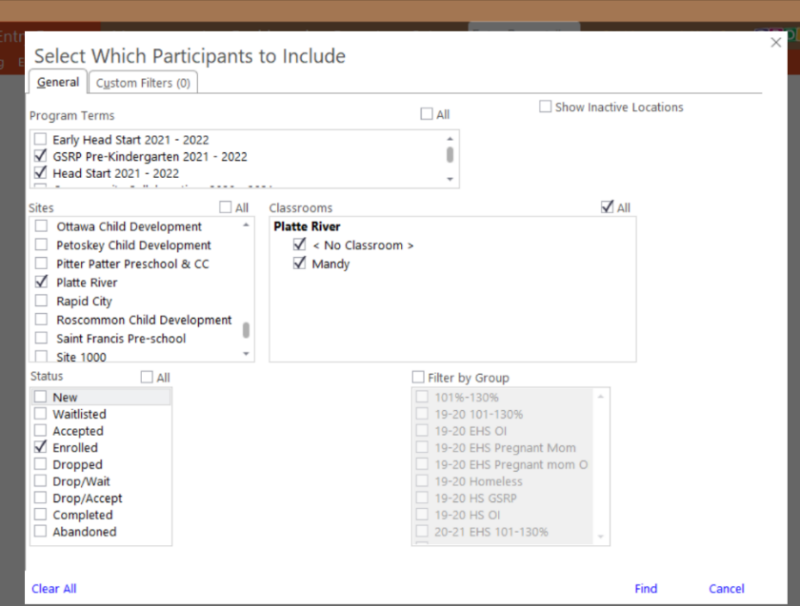

Select Which Participants to Include
Complete these fields:
- Program Term: Enter program term
- Sites: Select the sites you want to include
- Classroom: Select the classroom for the sites you selected
- Status: Select Enrolled
- Classrooms: Put a check mark next to the classrooms you want to include
Click Find at the Bottom of the Screen

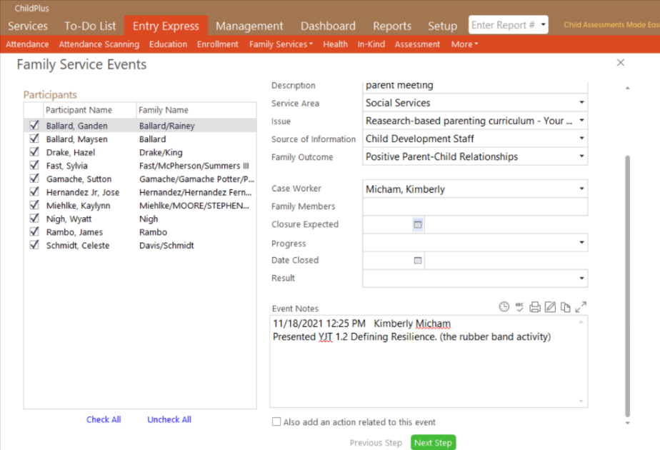
Enter Family Service Event Details
First, you will want to select the children you want to enter information for.
You do not have to enter the event information for all children in the class list. If you want to enter the event for all children, they will already have a check mark by their name when you get to this screen, If you click the box that says, “uncheck all”, you will be able to clear all check marks and then only put a check next to the children whom you wish to enter the event for.

Then, Complete these fields:
- Initial Date: Enter Date Event was held
- Event Type: Parent Engagement
- Description: state which type of event was attended
- Service Area: Select appropriate service area
- Issue: Select Research based parenting curriculum – Your Journey Together
- Source of Information: Select Child Development Staff
- Family Outcome: Select Family Outcome
- Case Worker: Select Case Worker

To Add an Action to this Event: (You may need to scroll down to find this box to check)

Click box that says Also Add an Action to this Event

Complete these fields:
- Action Type: Choose action type
- Action Date: Enter action date
- Type of Contact: Choose type of communication
- Description: Describe event
- Status: Choose appropriate status
- Case Worker: Enter case worker who did this action

Click on the Next Step at the bottom of the screen

Edit Events for Individual Participants as Necessary
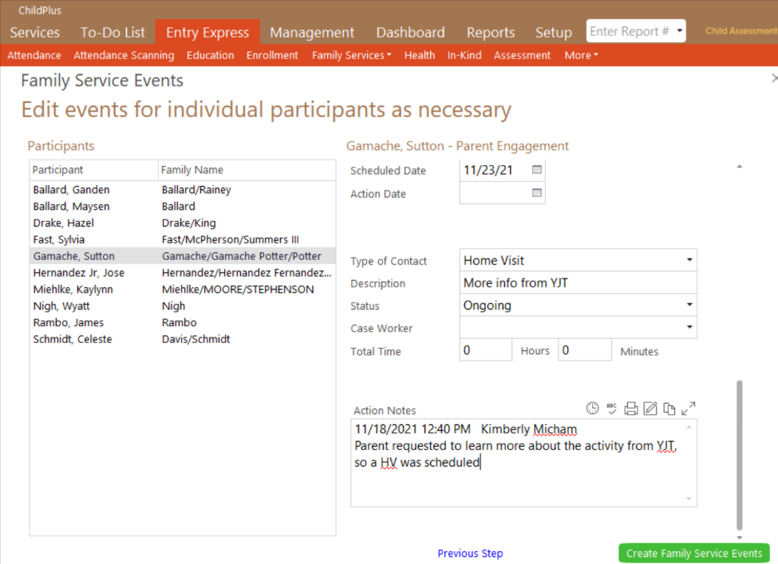
At this point you can change information for individual participants if you wish to enter something different for a specific participant. You will need to highlight the participant on the list of participants you selected. To do this, click on the participant you want to edit, and they will show up as highlighted in gray. You can change the event information in the fields to the right. You can edit as many individuals as you wish to edit individually. If you choose to edit another participant after entering the details of the first participant, you will just need to click on and highlight the next participant you wish to edit details for. The fields will automatically be saved with the new data you entered.
This is an example of someone requesting more information after the parent meeting YJT activity.

Click on Create Family Service Events at the bottom of the screen

To find your Dual Enrolled Families:
- CP Report 4012
- Click current term for EHS and HS
- Click “Each participant has at least one of the selected Status(s)”
- Open in Grid form
- Hover over the right-hand corner of the top of the Site column and click on the little arrow thingy.
- A list of sites and EHS counties will appear
- Click on your sites and your county (or counties)
It should then filter down to just the families that are dual enrolled for your sites. (I found a couple extra kids when I did this, it may not be a perfect system, but this was the best that Michelle and I could figure out)

