Cadillac and Roscommon Head Start

Family Engagement Specialist

Hello!

My name is Nicole Gonzalez and I work for Northwest

Community Action Agency in the Head Start Program. I have worked in the Human Service Field for 7 years. My role with your child’s preschool program is to:

* Offer home/virtual visits during during the school year.
* Partner with families to prioritize their family goals.
* Connect families to community resources and events.
* Work along side teachers to provide family activities.
* Encourage good attendance by collaborating with families to remove barriers.
* Provide opportunities for parents to attend parent engagement activities, either virtual or in-person.
* Offer opportunities to connect with other parents to help support each other during this parenting journey.
* Provide support to the teachers.

Let me know if you would like to learn more about the

opportunities that Head Start provides.

Contact Information

Address: 1640 Marty Paul

Cadillac, MI 49601

Phone: (231) 409

-

7427

Email: ngonzalez@nmcaa.net

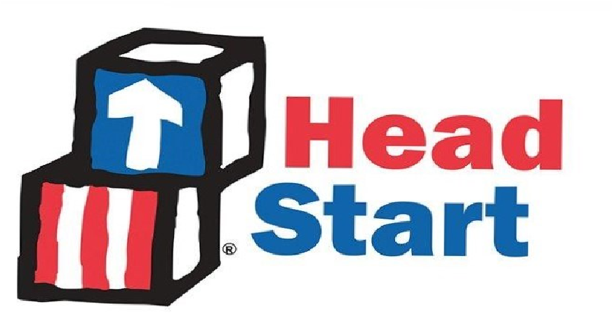

Nicole Gonzalez: HS FES

