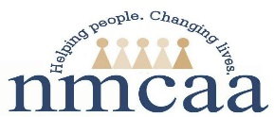 Monthly Credit Card Log
- Policy: Access and use of agency credit cards is a privilege. Cards are to be used for agency business only. NMCAA will monitor credit card activity using the Monthly Credit Card Log to ensure accurate records are maintained for audit and grant compliance. All receipts must be scanned/emailed to the businessoffice@nmcaa.net as purchases are made. CC your supervisor/coordnator. Failure to submit receipts will result in loss of card access and use.
Write the date, name of the store and the center location in the subject line before emailing. Example: 07292021 Walmart Marty Paul
Site: _______________________
Date & Time Checked Out | Authorized User Name | Card Name | Date & Time  Checked In | Date  Receipt Scanned
7/29/21  2:20pm | Kelly Stockfisch | Walmart Purchase Card | 7/29/21 4:00pm | As purchases are made

Distribution: Original kept with card, scan copy to Supervisor/Coordinator monthly
Reference: HS 1304.00
5/21 P:Head Start/Admin/Procedure Manual/Time-Expense-Training Time/Monthly Credit Card Log

