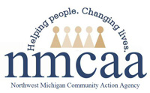

MiRegistry
Health and Safety Refresher Training 2020
Child care providers have a new requirement to complete ongoing health and safety training annually. The Michigan Ongoing Health and Safety Refresher Training 2020 is currently offered online and face to face. To find the online training or a face to face training, go to www.miregistry.org and enter "Refresher 2020" in the Keywords field on the Search for Training page. Or search by entering the Event ID# 45761.
This is a 2 hour training.
Deadline for training completion: Licensed Child Care Providers will have until October 31, 2020 to complete the Refresher.

www.miregistry.org

