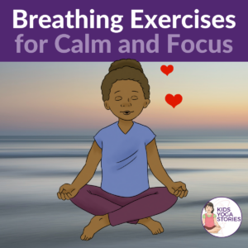

#1: LOVING KINDNESS BREATH
Choose a standing or comfortable upright position such as sitting in a chair, sitting cross-legged, or sitting on your heels. Close your eyes if that is comfortable and begin to tune in to the sound of your breathing. Take a deep breath in then slowly exhale for five counts. On your next exhale, think of filling yourself with love. Imagine the color red enveloping your body. On the next exhale, think of sending love and kindness to someone close to you. Then as you exhale, send loving kindness to someone you are having a difficult relationship with at the moment. Then send love and kindness out to the world around you: the animals, the trees, your neighbors, and your city. Lastly, send out love and kindness to the world. Finish your loving kindness breath by coming back to breathing naturally. When you are ready, open your eyes. This breath is great for Valentine’s Day celebrations or when you need to slow down to express more love to yourself and those around you.
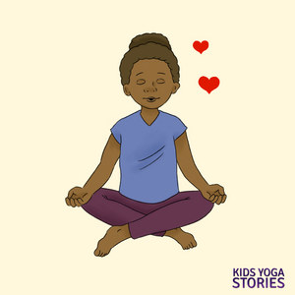Loving Kindness Breath

#2: FLOWER BREATH
Choose a standing or comfortable upright sitting position such as sitting in a chair, sitting cross-legged, or sitting on your heels. Close your eyes if that is comfortable and begin to tune in to the sound of your breath. Imagine you are holding a flower. Imagine the color and smell of that flower. Then take in a deep breath, pretending to smell that flower. Then exhale and pretend to blow the flower petals. Repeat the cycle of a strong inhale and gentle exhale for a couple of minutes, if possible. You could pretend to smell a different flower each time you inhale. You could also imagine yourself sitting in a meadow of fresh flowers. This flower breath is an easy way to help children become aware of their breath. You could also pretend to smell hot chocolate then blow the hot chocolate to cool it down. During fall, you could pretend to smell the fall air (inhale) and then blow leaves (exhale).
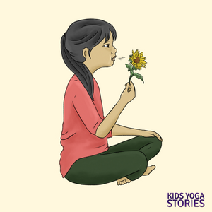Flower Breath

#3: WOODCHOPPER BREATH
Stand tall in Mountain Pose and take a few deep breaths. Then take your feet mat-width apart (a little wider than hip-width). Clasp your hands together in front of your body. Take a long breath in while raising your hands above your head. Then, on a vigorous exhale with your mouth open, forcefully take your hands down between your legs. Hang your head and completely let go of all the tension in your body. Close your eyes, if that feels comfortable, and repeat the steps: long exhale with hands overhead, followed by vigorous exhale while bringing your hands down between your legs. Pretend to be a woodchopper cutting a log for a campfire. Repeat this breathing technique a few times, allowing the children to find their own rhythm and become aware of their breath. Stand tall in Mountain Pose again and come back to breathing naturally. Let the children feel the effects of this energizing breathing technique. Instead of a woodchopper, you could pretend to be an elephant drinking water from a lake with your trunk (clasped hands) then swinging your trunk over your head to spray water over your back. This is a great breathing exercise for releasing stress and extra energy.
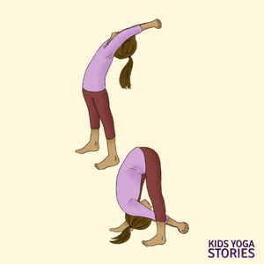Woodchopper Breath

#4: BEE BREATH
To practice bee breath, come to sitting comfortably with a tall spine and your shoulders back. Close your eyes or gaze gently down in front of you. Take a few deep breaths to calm your mind and body. Come to the present moment. Breathe in and out through your nose with your mouth closed.
As you exhale, keep your mouth closed and make a long “mmm” sound, pretending to buzz like a bee around the garden. Then inhale through your nose, keeping your mouth closed. Repeat the bee humming sound on the next exhale. Continue in this way with an extended inhale, followed by a humming exhale for a few minutes or as long as it feels comfortable. When you are ready, open your eyes and breathe naturally. Notice if you feel any differently after practicing bee breath. You could also cup your hands over your ears to intensify the “mmm” sound.
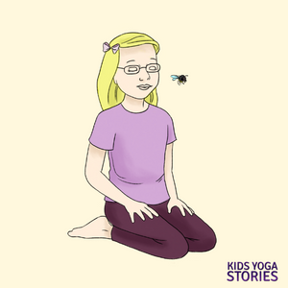Bee Breath

#5: DEEP BELLY BREATH
This one is also known as “yogic breathing.” To practice this deep belly breath, choose a comfortable upright position such as sitting in a chair, sitting cross-legged, or sitting on your heels. Or come to lying on your back in a resting position. Place your right hand on your belly and your left hand on your chest. Take a deep breath in for four counts then exhale through your nose for four counts, with your lips closed. Feel the rise and fall of your chest and belly. If you’re on your back, you could place an object, like a stuffed animal, on your belly to help feel (and see) the rise and fall of your belly.
Do this deep belly breathing for a few minutes. Give your child a few times to get comfortable with this style of breathing. You could use a Hoberman sphere as a visual cue to show your children the inhaling and exhaling action. Children can think of different things that they are grateful for during each inhale and exhale.
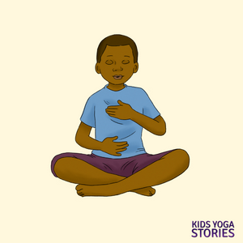Deep Belly Breath

