Head Start/GSRP Class Selection and
Intermediate School District Guidance 2021-22
This is class selection guidance for NMCAA Child and Family Development Programs
Policy: 1302.15 (a) Funded Enrollment: A program must maintain its funded enrollment level and fill any vacancy as soon as possible. A program must fill any vacancy within 30 days.
Run an Enrollment Priority Listing – Report 2025 in ChildPlus
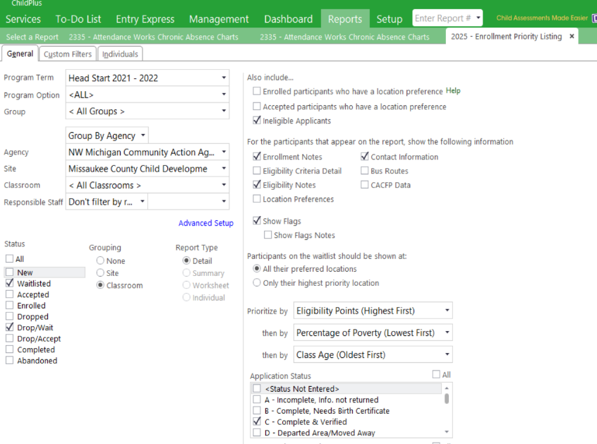
- Choose Program Term 2021-2022 (if running for two programs, see Advanced Set Up).
- Choose the site
- Under Status, choose Waitlisted and Drop/Wait
- Under Also Include, choose Ineligible Applicant In order to see children not 3 years old by 9-1,
- Under the For the participants that appear on the report, show the following, check Enrollment Notes, Contact Information and Eligibility Notes.
- Click Show Flags-Flags will indicate specific details regarding the child.
- Under Application Status, choose C-Complete and Verified
.
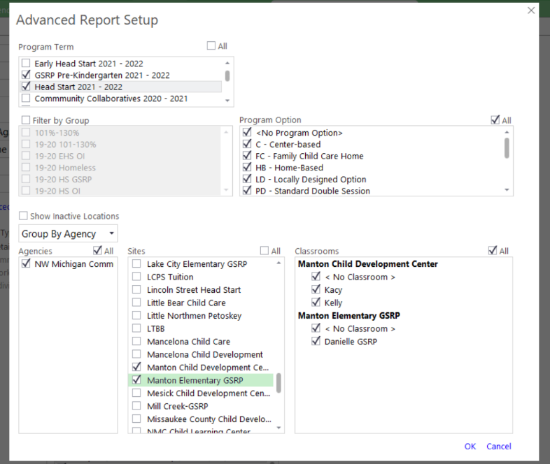
Using Advanced Setup
In areas where there are multiple classrooms (Manton and Manton GSRP), use Advanced Setup to view all children’s eligibility point totals on each Enrollment Priority Listing. We ae able to use multiple waitlists when looking to add the most eligible child. For example, Manton waitlist has over income four-year old children on their waitlist and Manton GSRP needs another child. Staff can look at both waitlists to determine who is the most eligible child. Select the multiple program terms and sites you want to see and click ok. Click none under grouping then preview. The notes will have the families’ first and second preference. Be sure to communicate with ERSEA Manager prior to accepting a child from a different waitlist to ensure the child’s status.

All Application Files will be uploaded into ChildPlus under the application tab. After printing the waitlist, FES or Education Coach will compare all applications to the waitlist prior to making a class list to ensure that all eligibility information is correct. Application Files must be on site before enrolling (child’s first day in classroom) a child into a program. Teachers, FES and Education Coach’s can print the application from ChildPlus. Classroom files will only need the verification page and pages 1 and 2 of the application for their child files.

General Considerations Prior to Making a Class Selection
- Teachers, Education Coaches and FES should have an idea about who will be returning and who will not. Review the waitlist to ensure that all expected returning children are on the report. If there are applicants not on the waitlist that are expected to be, communicate with the R&H or ERSEA Manager regarding incomplete applications.
- EHS staff will communicate with FES and Education Coaches regarding EHS transitioning children.
- ERSEA Manager and DMT will update the slot chart and distribute it out.
- R&H will communicate with ERSEA Manager regarding low numbers in areas and recruitment efforts. The Program Director will discuss further plans.
Age Eligibility
- Refer to the Age Eligibility Chart for 2021-2022 School Year
- A HS child must be 3 by September 1
- EHS children, turning 3 between Sept 2 and Dec 1 will be considered after September 2. A 3 Year Old Waiver will be completed by the families.
- Coaches/FES and Education Coach Manager will decide on an individual basis if non-EHS children (turning 3 between Sept 2 and Dec 1) will be accepted into a HS classroom. A 3 Year Old Waiver will be completed by the families.
- GSRP children must be four on or before September 1
- Children that turn four after September 1, but on or before December 1, can be considered for early entry after September 2 for a HS/GSRP Blend or 100% GSRP Slot.
- Children are age eligible to be enrolled in Head Start any time during the school year when they turn three.

Prioritizing

- Head Start and Early Head Start applications are prioritized based on priority points designated by the HS and EHS Enrollment Priority Criteria.
- 100% GSRP classrooms are prioritized on the Federal Poverty Level. If two children have the same Federal Poverty Level, then the number of eligibility factors will rate them.
- Returning 2nd year GSRP children need to be reprioritized based on their new Federal Poverty Level with a new application.
- HS/GSRP blended children need to: (1) be Head Start income eligible; (2) have a 2021 application or recert; (3) be age eligible for GSRP; (4) live in the school district/ISD where the GSRP slots are allocated.
- Children determined to be in foster/kinship care, homeless children, or families receiving Supplemental Security Income (SSI) or Family Independence (FIP) are eligible for Head Start and GSRP.
Children with IEPs, GSRP or Head Start Over Income, 101-130%, Children Related to NMCAA Staff, and Custody/Attendance Issues
- Education Coaches and/or FES will inform the Education Manager prior to accepting children with an IEP. The Education Manager will review the IEP to ensure best placement.
- Education Coaches and/or FES will communicate with the ERSEA Manager regarding placing Over Income children, children related to NMCAA staff, and custody/attendance issues. ERSEA Manager will discuss individual situations with Program Director for approval.
- Over Income GSRP children (over 250% FPL), will be reviewed as needed. Requests will be sent to the ISD by the ERSEA Manager.
- Returning children that were designated as 101-130% FPL or Over Income in the 2020-2021 school year are not guaranteed placement the 2021-2022 school year. Coaches/FES will communicate with the ERSEA Manager regarding the options for getting these children back into HS or placed into GSRP. Please refer to Enrolling 101-130% Federal Poverty Level and Over Income.

GSRP children living outside ISD Service Area
- GSRP children that are out of the ISD Service area need approval from the ISD before the child can be accepted. ERSEA Manager will submit the request to the ISD.
Class Selection
- When selecting children, there are 6 different criteria that need to be considered:
1) Priority Points, 2) Family Income, 3) Whether child is homeless or in foster/kinship care, 4) Child’s Age, 5) Child is Eligible for Special Education or related services, and 6) Family or Child Risk Factors.
- FES and Education Coaches will work with the teachers to make the class selections if applicable. Classrooms in Char-Em will be done with a committee.
- Once initial class lists are approved by the ERSEA Manager, the Coach/FES will email the Class Selection Worksheet to DMT and R&H.
- Children that are 101-130% of the federal poverty level, a waitlist must be attached to the worksheet when submitting to DMT. The waitlist will have notes indicating why a 101-130% child was selected.
- 2 open slots will be left open in each program. HS and HS/GSRP blended programs can fill in August.
Accepting Children
During the Summer Months (June-August)
After the class list is approved, it is our goal for all families to receive a phone call communication for welcoming the families into our program. This gives the family an opportunity to ask questions and have a plan for the fall, it also gives staff the opportunity to share any expectations of the family prior to the first day of school. This should be a warm welcoming to the families to know how excited we are to have them part of our program and all the services we have to offer. Communication with the families regarding acceptance can be done in any of the following ways:
    - FES will call the families and accept them.
    - FES or Education Coach will give the teachers the okay to call the families and accept them. If a teacher is laid off for the summer, one day worth of work hours has been approved for them to do this.
- Education Coach can call the family and accept them, as this should not be the first choice.
- In August, FES and Education Coaches will communicate with Teachers regarding filling their class list. The ERSEA Manager will approve the class selection. A Change of Status will be completed and emailed to DMT and R&H.
- Acceptance packets will be mailed to the families once the R&H receive notice using the Class Selection Worksheet.
- Talking Points and reminders when calling families to accept them in the program:
    - Let them know they will be receiving an acceptance packet in the mail and encourage families to complete the health requirements.
    - Let them know that in August they will have an orientation/home visit/open house before school starts.
    - Verify their mailing address and phone numbers (complete a change of status if any changes and email to DMT).
    - Ask the family if they are interested in any resources or information for their overall family needs and wellness. Our program can facilitate a variety of referrals.
- FES and Education Coaches will communicate with ERSEA Manager, DMT, Teaching Staff and R&H about adds and drops during the summer.
- DMT will mark children as accepted on ChildPlus. Staff can see their accepted Class Selection using Report 2110. Once a child is Enrolled, they will then be marked Enrolled on Report 2110.
- Children that are not accepted and, on the waitlist, a Waitlist letter will be sent to these families at the end of August.

During the school year
- FES and Education Coach’s will communicate with the teacher regarding a vacancy in the program. A current waitlist will be used to determine the next eligible child to be accepted. FES or the teacher can call the family to welcome them into the program.
- FES and Education Coach will communicate with PSC (EHS) when accepting a currently enrolled EHS child.
- Once the FES or teacher have accepted the child, a Change of Status will be completed and emailed to DMT, R&H and ERSEA manager indicating the date of acceptance. R&H will send the family an acceptance packet with health information.
- The teacher will then schedule the orientation paperwork with the family as soon as possible. As a reminder, we have 10 days to fill a vacant spot.
- When the child has come to school, a Change of Status will be completed either by the FES or Teacher, indicating the child’s first day of school. This will be their Enrollment Date. The Change of Status will be emailed to DMT, R&H, Education Coach and ERSEA Manager.

Intermediate School District Additional Guidance 2021-2022 Acceptance
All ISD’s in our service area:
- Each ISD has their own tuition policy. The ERSEA Manager will seek permission from the ISD to enroll an over income family that will need to pay tuition.
- We are required to sign a GSRP Release to Serve form and have it in our file for our children in our 100% classrooms that are HS eligible. We are also required to sign this form for eligible HS children served in a community collaborative GSRP.
Char-Em
- We can fill our 100% GSRP slots in Aug/Sept – we do not have to leave slots open after start up.
- No IEP’s will be categorically eligible in Char-Em. The ISD does not write their IEP’s to recommend a child in an inclusive classroom.
- Accepting children across ISD borders will require an agreement between those ISD’s and prior approval.
TBAISD
- Do not place any GSRP children that are over income (over 250% FPL) even if they have an IEP. If we had any of these children in question we would need to seek approval by the specific ISD.
- TBAISD would like our 100% GSRP classrooms to leave at least two slots open until school starts.
- It is okay for us not to have backup income documentation in our HS/GSRP blends and 100% GSRP children’s files. They just need a signed income verification form in the child’s file.
- Accepting children across ISD borders will require an agreement between those ISD’s and prior approval. TBAISD also has a form regarding this that parents will need to sign.
Wexford / Missaukee ISD
- Ensure that all eligible GSRP children and GSRP blended children on the Enrollment Priority Listing are enrolled in their home school district, before children from another school district would be able to be added as a school of choice.
- Do not place any GSRP children that are over income (over 250% FPL) even if they have an IEP. Any of these children in question we would need to seek approval by the specific ISD.
- Wexford/Missaukee would like our 100% GSRP classrooms to leave at least two slots open until school starts.
- Accepting children across ISD’s will require an agreement between those ISD’s and prior approval.
COOR ISD
- We can fill our 100% GSRP and HS blended slots in Aug/Sept – we do not have to leave slots open after start up.
- We do need to use the COOR data base and abide by timelines for contact with families or notify COOR if we are getting bogged down.
- HS OI children need to be marked as waitlisted as soon as it’s determined they will not be served by Head Start.
- Ensure that returning 3-year-olds (now four) are marked in the COOR Data base as returning to us.
For further guidance, refer to GSRP Eligibility Guidance in the GSRP Implementation Manual.

