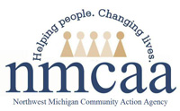
Multiple Positions Available
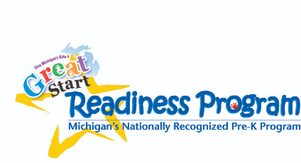
APPLY ONLINE at www.nmcaa.net or SCAN NOW!
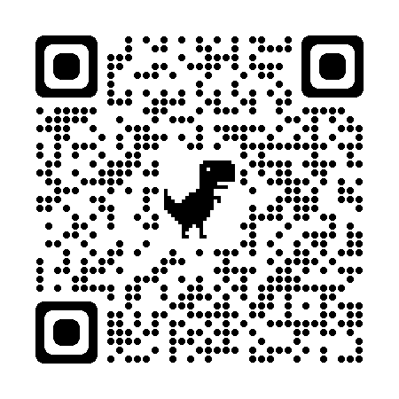

Help make a positive impact in the lives of children and families!
We will provide training! No experience necessary!
Come join our team!
This Photo by Unknown Author is licensed under CC BY-NC-ND

6/2023 Original to be posted in the Parent Corner HSPPS 1302.90 (6) EHS-HS Team\Admin\Procedure Manual\Postings\Help Wanted Sign

