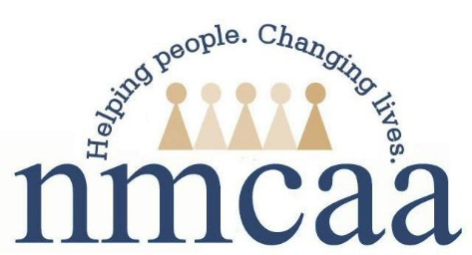

NMCAA’s Child and Family Development
Health Services Advisory Committee Purpose
Policy: 1302.40
- A program must provide high-quality health, oral health, mental health, and nutrition services that are developmentally, culturally, and linguistically appropriate and that will support each child’s growth and school readiness.
- A program must establish and maintain a Health Services Committee that includes Head Start parents, professionals, and other volunteers from the community.
The purpose of the Health Services Advisory Committee (HSAC) is to participate in planning, operation, and evaluation of program health policy and procedures This committee also assists the program in meeting its goal of establishing community partnerships and developing collaborative relationships and agreements with community agencies and organizations.

The range of functions of the committee includes:
- Assisting the program in meeting the Head Start Performance Standards and NMCAA Safety and Emergency Preparedness Plan.
- Identifying health and wellness needs of children, families, staff and communities through the Community Assessment, Family Needs Assessment, Application Packet, family goal process and reflective practice.
- Identifying health and wellness barriers and finding supports to overcome those barriers (physical, mental, and dental).
- Review current policies and procedures regarding health.
- Assisting Child Family Development Programs to identify health and wellness resources within the community to establish collaborative relationships.
- Guest speakers (families, staff and professionals) will extend our knowledge in focus areas.
- Acting as child health advocates within the greater community.

