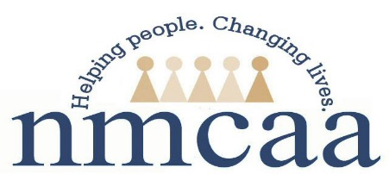

Head Start Reactivation 2019
Return to Work Verification

Please Complete the Following:

SSN: _______ _____ _______ (Entire Number)
First Name: _____________________________
Last Name: _____________________________

First Day Back to Work (regular schedule): ___/ ____/ 2019
Address: ___________________________________________________
City: ______________________________________________________
Zip Code: ____________________

All of the above information is required to report to the State of Michigan for your employment Status.

Employee Signature: ___________________________________________________
Date: ____/____/ 2019

This form is to be sent immediately upon completion to:
Betsy Rees, Human Resources Manager

3/2019 P:\Head Start\APOT\APOT Documents\2019-2020 APOT Documents\Head Start Reactivation Form

