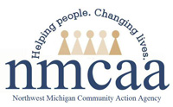

NORTHWEST MICHIGAN COMMUNITY ACTION AGENCY, INC.
EARLY HEAD START/HEAD START/GSRP
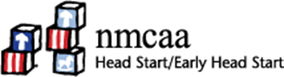

Program Grievance Form

It is the policy of the NMCAA, Head Start/Early Head Start/GSRP program to afford program participants and the general community the opportunity to provide feedback about program services, delivery systems, or constructive criticism of the program delivery system. If you are a GSRP parent and are not satisfied with NMCAA's service, you can contact your local ISD office. To schedule an interview regarding your grievance or complaint, please complete the form below and send it to:

NMCAA
Early Childhood Programs
3241 Racquet Club Drive, Suite A
Traverse City, MI 49684

You will be notified of a grievance review which will be scheduled within thirty (30) working days of the receipt of your request.

Name:_____________________________________________________________________________

Address:___________________________________________________________________________

County:________________________________________Telephone:_________________________

Nature of Situation:_______________________________________________________________

____________________________________________________________________________________

____________________________________________________________________________________

____________________________________________________________________________________

Signature:____________________________________________________Date: ________________

Reference: Head Start Act Sec. 642(c)(1)(E)(iv)(X)(bb), GSRP Program Administration and Staffing
5/23 EHS-HS \ADMIN\Procedures manual\Miscellaneous\Complaint-1.doc

