Site Name: ______________________________________________
Return this completed form to: NW Michigan Community Action Agency Inc. 3963 Three Mile Road, Traverse City MI 49686 (231)947-3780 or 1-800-632-7334

Household Income Eligibility Statement – Child Care Institutions

Part 1 – Households Receiving Food Assistance Program (FAP), Family Independence Program (FIP), or Food Distribution Program on Indian Reservations (FDPIR) If any member of your household receives FAP, FIP, or FDPIR, provide the name and case number for the person who receives the benefits.
Name: Case Number:

Part 2 – Household Information How Often? (x) How Often? (x) How Often? (x)
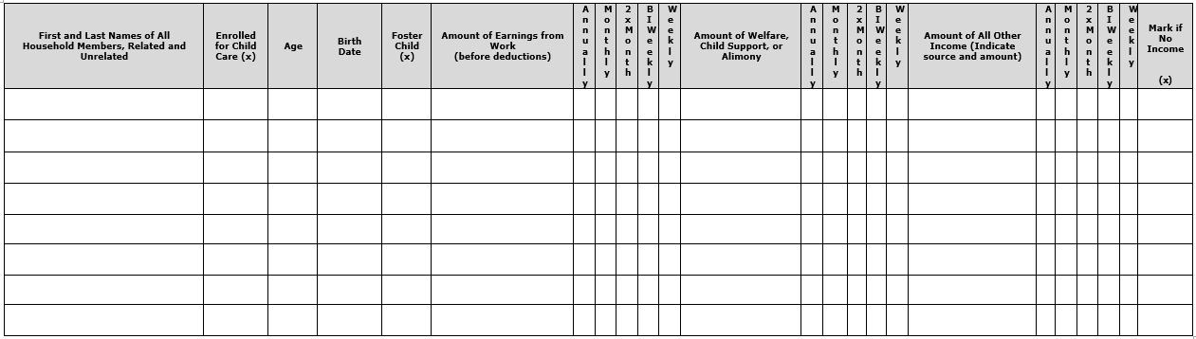
Part 3 – All Households: Signature and Last Four (4) Digits of Adult Social Security Number (Adult household member MUST sign and date)
I certify that all information on this form is true and that all income is reported. I understand that the center or day care home will receive federal funds based on the information I give. I understand that CACFP officials may verify the information. I understand that if I purposely give false information, the participant receiving meals may lose the meal benefits, and I may be prosecuted.
Signature: Print Name: Date: _
Last four digits of Social Security Number: XXX-XX-_ _ _ _ I do not have a Social Security Number
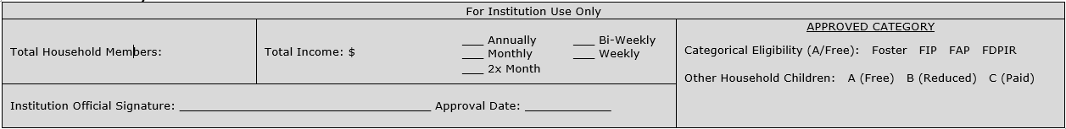
For Institution Use Only:
This form is valid for 12 months from the date of institution signature. Approval date and institution signature are required.

Privacy Act Statement
The Richard B. Russell National School Lunch Act requires the information on this application. You do not have to give the information, but if you do not, we cannot approve the participant for free or reduced price meals. You must include the last four digits of the Social Security Number of the adult household member who signs the application. The Social Security Number is not required when you apply on behalf of a foster child or you list a Food Assistance Program (FAP), Family Independence Program (FIP), or Food Distribution Program on Indian Reservations (FDPIR) case number for the participant or other FDPIR identifier or when you indicate that the adult household member signing the application does not have a Social Security Number. We will use your information to determine if the participant is eligible for free or reduced price meals, and for administration and enforcement of the Program.

Non-Discrimination Statement
In accordance with Federal civil rights law and U.S. Department of Agriculture (USDA) civil rights regulations and policies, the USDA, its Agencies, offices, and employees, and institutions participating in or administering USDA programs are prohibited from discriminating based on race, color, national origin, sex, disability, age, or reprisal or retaliation for prior civil rights activity in any program or activity conducted or funded by USDA.

Persons with disabilities who require alternative means of communication for program information (e.g. Braille, large print, audiotape, American Sign Language, etc.), should contact the Agency (State or local) where they applied for benefits. Individuals who are deaf, hard of hearing or have speech disabilities may contact USDA through the Federal Relay Service at 800-877-8339. Additionally, program information may be made available in languages other than English.

To file a program complaint of discrimination, complete the USDA Program Discrimination Complaint Form, (AD-3027) (http://www.ascr.usda.gov/complaint_filing_cust.html) online, and at any USDA office, or write a letter addressed to USDA and provide in the letter all of the information requested in the form. To request a copy of the complaint form, call 866-632-9992. Submit your completed form or letter to USDA by: (1) mail:
U.S. Department of Agriculture, Office of the Assistant Secretary for Civil Rights, 1400 Independence Avenue, SW, Washington, D.C. 20250-9410; (2) fax: 202- 690-7442; or (3) email: program.intake@usda.gov. This institution is an equal opportunity provider.
Rev 6/2019

