What is In-Kind and how do I submit my In-Kind assignment? In order to fund your child’s classroom or home visiting program, we must receive 20% of our total funding from local donations of time, money, materials, and services. This funding source is called In Kind. This means we need help from parents and the local community to continue to operate our Head Start program. Parent involvement in their child’s education is key to their future success and In Kind is a great way to be involved.
Our program is using the Learning Genie App to collect In-Kind activities digitally. Doing so will help us save paper (trees), save time for staff, and will support our funding needs.

It's easy to submit an In-Kind assignment to your child's teacher using the Learning Genie parent app. Here's how!

After your child's teacher or home visitor assigns an activity to you, you will be notified with an offline message or a pop-up notification whenever you log into the App.

Click the "View Details" button to see the assignments that you need to complete.
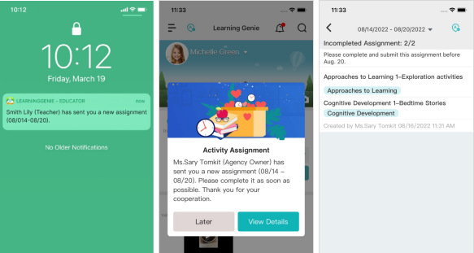
Select an activity, and enter data, time, and comments (if any). Then, Sign and submit.
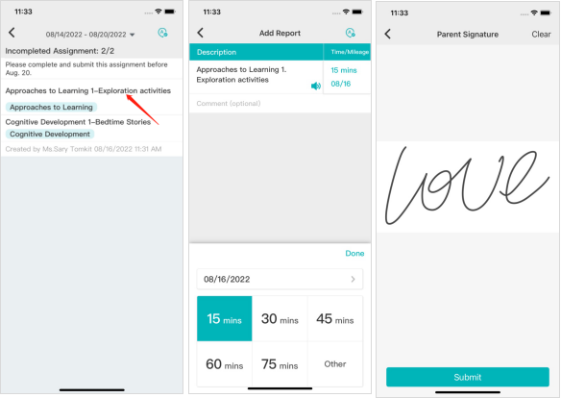

On the Home page
You can also view the teacher assigned activities on the Home page.
Click the "Submit" button to submit your assignment.
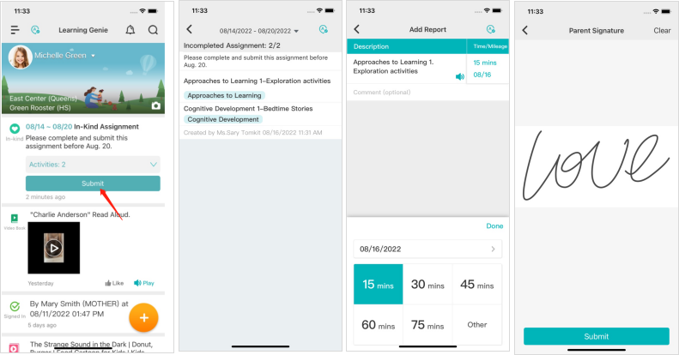

How to Add Time for other Volunteer Activities or Program Requirements
Time and mileage spent driving to and from program required activities, such as dental appointments and well child checks, can also be counted as In-Kind. So can time spent on activities such as completing Needs Assessments and other program surveys (Family Outcomes Tool, e-DECA, etc.) and activities (Your Journey Together).
To share this information with your teacher or home visitor
- Click the three lines at the upper left of your app
- Click “In-Kind report”
- Click “+ add”, at the bottom of the app.
- Select either “Volunteer” or “Mileage” at the bottom of the app., as appropriate.
To record Volunteer time:
- Under “Volunteer,” select the requirement you completed (travel time to physical or dental, Family Outcomes Tool, Your Journey Together, etc.), then click “Select.”
- Enter the amount of time you spent completing the required activity (travel time would be total time in the car, both to the appointment and back- do not count time spent at the appointment). You can select a preset time or click “Other” to enter a more accurate amount of time.
- Select “Done, then “Submit.”
- Add your signature and select “Submit.”
To record Mileage:
- Under “Mileage” select the requirement you completed (typically physicals/well child visit or dental, but others may apply), then click “Select.”
- Enter your round trip mileage, then click “Done.”
- Click “Submit.”
- Add your signature and select “Submit.”

