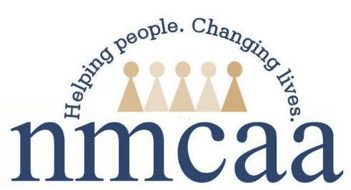

Cultural Competence Plan
The purpose of the cultural competence plan is to develop a system that can effectively provide services to children and families of all cultures, races, ethnic backgrounds, and religions in a manner that recognizes values, affirms, and respects the worth of the children and families and protects and preserves the dignity of each. NMCAA believes that by addressing the cultural and linguistic needs of our children and families, it will improve access to health care, quality of education and better school readiness outcomes. It is important to value the culture, ethnicity, race and religion in the delivery of services that NMCAA provides to ensure a comprehensive and coordinated plan that includes interventions on levels of policy and procedures making, program administration and evaluation, and most importantly quality programming for all enrolled in the program.
NMCAA has many partnerships that help to ensure the cultural competence plan is executed. The agency works with four Intermediate School Districts in its service area, along with Early On in each district. Each ISD/Early On program brings a unique support based on their resources and capacity. They provide special education services to ensure all children are receiving education experiences based on their needs. They also provide Early Childhood Specialist to do observations in the classrooms to monitor the cultures of the classroom are represented and activities are planned to support these cultures. Early On staff complete home visits, in collaboration with the home visitors when possible, join socializations and visit our center based EHS options ensuring all children’s needs are being met. The Resource Center provides resources and support through trainings that are offered in the 10 different counties NMCAA serves. Head Start provides programs with the resources they need to purchase classroom/home visiting materials and equipment to support the plan. There are activities planned through language experiences, creating food from different cultures, celebrations, books, dolls so that currently enrolled children and families are reflected in the lesson/home visiting plan experiences each week. The parents have a section on the lesson/home visiting plan where staff reach out to them to get ideas to support the study that is taking place that week. Many times the family’s culture is represented in the activities and we encourage parents to visit the classroom and assist in planning the home visit activities to implement the activity ideas they shared.
This information is shared with families through many different mediums: parent handbook, parent meetings, family engagement events, newsletters, visits to the classrooms, informal conversations, home visits, and parent teacher conferences. NMCAA staff are culturally sensitive in their interactions with children and families. The staff are trained and coached to understand and respect each family and the uniqueness that each of them bring to the program.

5/22
P:\Head Start Files\ADMIN\Procedure Manual\Education-Disabilities\Cultural Competence Plan

