Creating In-Kind General Weekly Assignments in Learning Genie–

iPad or iPhone (photos are for iPad instructions)
You can send In-Kind assignments to families and track the completion progress now. Here is how.
- On your iPad, log into your Learning Genie App, and click the “Settings” icon. Then, go to “Useful Features” > “In-kind”.
- On your iPhone, log into your Learning Genie App, click on the three bars at the upper left of your screen and then click “in-Kind Report”
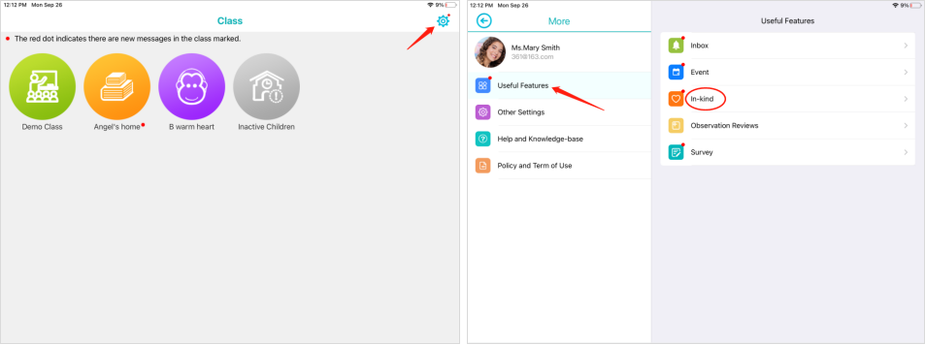
or
- On your iPad, click on a classroom, go to “More”. Then, tap “Useful Features” and select the “In-kind” option, you can also access your assignments.
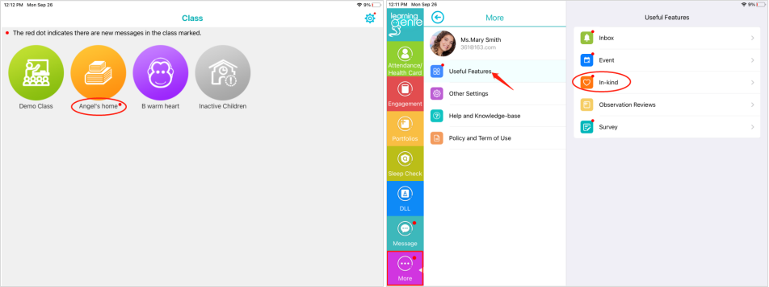
- To create an assignment on your iPad, go to "Activity Assignment", and click the "Create Assignment" button.
- To create an assignment on your iPhone, simply click the “Create Assignment” button.
Note: if you already have some assignments for this month, please click the “+” icon to create a new assignment.
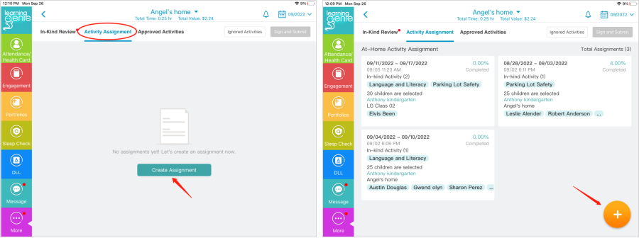
- Select the at-home activities that you are going to include in this assignment. As a general rule, this is simply the current month and the week of the month we are in, as of Monday of the current week. If you would like to include a literacy activity for the week.
  - You can also click on “Weekly Extension Activity” if you will be adding an activity that is individualized for your classroom. These activities must be connected to the curriculum or another approved source in order to count as in-kind. Information on this activity must be added in the comment section.
- Click “select.”
- Next, select “weekly” as the type of assignment and then select the timeframe (week) that you would like to assign the activity for.
- In the comment section, make a note to families that you look forward to hearing about the time they spend with their children on activities listed in the home activity and movement calendars, or other assigned activity.
- You can send home hard copies of the monthly calendar or click the camera button, in the comment section, to include pictures of the activity calendars for families to view.
- Click the “Select Sites and Classes” button to include the class or individual child(ren) that you want to send the activity to.
  - If you are on your iPhone, do not click the check box to the left of the site name, unless you wish to include an entire site. Instead, click the actual class or site name. Example: “Alanson Child Development” then “Alanson Clsrm 1.” You can drill down further to individual children by clicking “Alanson Clsrm 1.”
  - Once you see the site, classroom, or child(ren), you want to include, click in the box to the left of the site or classroom name, or names of children, and then click the checkmark in the upper right corner of the screen (after “Select Sites and Classes).
- At last, click the “Submit” button to send this assignment to families to complete.
Note: you can also customize your comments/instructions, images, and attachments if you want to explain this assignment in more detail.

Creating In-Kind General Weekly Assignments in Learning Genie–
Computer
You can send In-Kind assignments to families and track the completion progress now. Here is how.
- Go to “Manage Family Engagement” > “In-Kind Report”. Then, select Activity Assignment, and click the “Create Assignment” button.
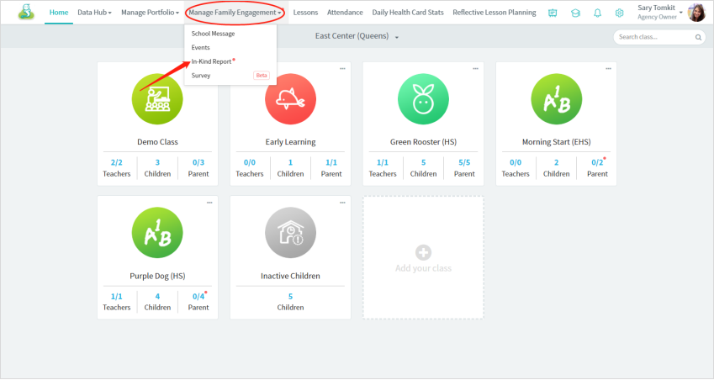
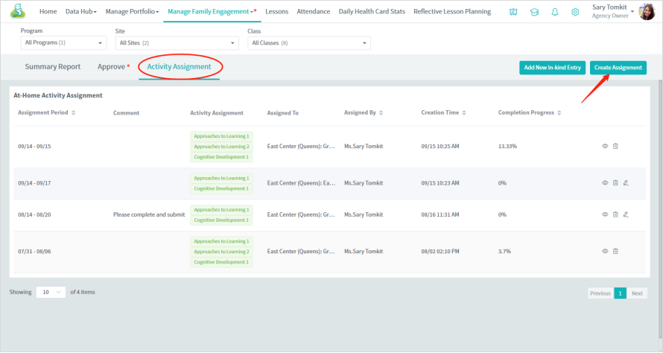
- Select this assignment type (weekly)
- Then, select the at-home activities you will include in this assignment.
- Click the “Select Sites and Classes” button to include the children you want to send.
- At last, click the “Save” button to send this assignment to families to complete.
Note: you can also add some comments/instructions, images, and attachments if you want to explain this assignment in detail.
