Northwest Michigan Community Action Agency
COVID-19 Mitigation Policy
This policy is based on information and guidance from the Centers for Disease Control (CDC) and the Michigan Occupational Health and Safety Administration Emergency Rules (MIOSHA) at the time of its development. Because the COVID-19 situation is frequently changing, the need for modifications may occur based on further guidance provided by the CDC, OSHA, and other public officials at the state or local levels.

COVID risk map- considerations for levels/tiers can be found here:
https://www.cdc.gov/coronavirus/2019-ncov/your-health/covid-by-county.html

The spread of COVID-19 in the workplace can come from several sources:
- Co-workers
- Customers
- Guests - visitors/vendors/family members
- The General Public
Staff members should refer to the NMCAA Personnel Policies, section A-2, for NMCAA’s Communicable Disease Policy: https://www.nmcaahr.com/policies.html

Definitions. As used in this plan:
(a) “Close contact” means close contact as defined by the latest United States Centers for Disease Control and Prevention (CDC) guidelines at the time of contact.
(b) “COVID-19” means a viral respiratory illness characterized by symptoms defined by the CDC.
(c) “Known cases of COVID-19” means persons who have been confirmed through diagnostic testing to have COVID-19.
(d) “SARS-CoV-2” means the novel coronavirus identified as SARS-CoV-2 or a virus mutating from SARS-CoV-2 (severe acute respiratory syndrome coronavirus 2), the virus which is the causative agent of COVID-19.
(e) “Suspected cases of COVID-19” means persons who have symptoms of COVID-19, but have not been confirmed through diagnostic testing.
(f) “Fully vaccinated persons” means persons for whom at least 2 weeks have passed after receiving the final dose of an FDA-approved or authorized COVID-19 vaccine.

RESPONSIBILITIES OF NMCAA SUPERVISORS AND MANAGERS
NMCAA designated the following staff as its COVID-19 Workplace Coordinators:

NAME | Email/Phone
Kaylee Lovejoy | klovejoy@nmcaa.net/231.346.2122
The Coordinator’s responsibilities include:
- staying up to date on federal, state, and local guidance
- incorporating those recommendations into our workplace
- training our workforce on control practices, proper use of personal protective equipment, the steps employees must take to notify our business of any COVID-19 symptoms or suspected cases of COVID-19.
- reviewing HR policies and practices to ensure they are consistent with this Plan and existing local, state, and federal requirements

All NMCAA managers/supervisors must be familiar with this Plan and be ready to answer questions from employees. Additionally, NMCAA expects that all managers/supervisors will set a good example by following this Plan. This includes practicing good personal hygiene and jobsite safety practices to prevent the spread of the virus. Managers and supervisors must encourage this same behavior from all employees.

Mitigation Strategies

Workplace Controls

(1) NMCAA shall provide space for individuals to practice social distancing, to the maximum extent feasible, while on worksite premises.
(2) NMCAA shall provide non-medical grade face coverings to employees at no cost to the employee.

(3) Remote Work
In-person work is allowed. Staggered work schedules may also be considered for shared spaces. Please see supervisor for scheduling and remote work options.
(4) Clients and Visitors
Employees must follow the NMCAA Client Protocol (Exhibit A) for all in-person appointments.

Basic Prevention Measures

(1) NMCAA shall promote frequent and thorough hand washing, including by providing workers, customers, and worksite visitors with a place to wash their hands. If soap and running water are not immediately available, NMCAA can also provide antiseptic hand sanitizers or alcohol-based hand towelettes containing at least 60 percent alcohol.

(2) NMCAA shall require workers who have been diagnosed with COVID-19 to not report to work.

(3)As needed, NMCAA will provide facility cleaning and disinfection to limit exposure to SARS-CoV-2, in accordance with the latest CDC guidance.

(4) NMCAA shall use Environmental Protection Agency (EPA)-approved disinfectants that are expected to be effective against SARS-CoV-2 based on data for harder to kill viruses.
(5) Enhanced Hygiene
Employees are instructed to wash their hands frequently, to cover their coughs and sneezes with tissue, and to avoid touching their faces. Employees will be provided with access to places to frequently wash hands or to access hand sanitizer. Employees will also be provided with access to tissues and to places to properly dispose of them. Signs regarding proper hand washing methods will be posted in all restrooms.

Signage promoting proper handwashing and the importance of personal hygiene will be strategically posted at all NMCAA buildings and facilities.

(6) Enhanced Cleaning and Disinfecting
Increased cleaning and disinfecting of surfaces, equipment, and other elements of the work environment will be performed regularly.
Health Surveillance

(1) NMCAA shall direct employees to promptly report any signs and symptoms of COVID-19 to the employer before or during the work shift.

(2) NMCAA shall physically isolate any employees known or suspected to have COVID-19 from the remainder of the workforce, using measures such as, but not limited to:
(a) Not allowing known or suspected cases to report to work.
(b) Sending known or suspected cases away from the workplace.
(c) Assigning known or suspected cases to work alone at a remote location (for example, their home), as their health allows.

Suspected or Confirmed Cases of COVID-19
NMCAA will follow the CDC guidelines, which can be found by following this link:
https://www.cdc.gov/coronavirus/2019-ncov/index.html

Confidentiality/Privacy
Except for circumstances in which the NMCAA is legally required to report workplace occurrences of communicable disease, the confidentiality of all medical conditions will be maintained in accordance with applicable law and to the extent practical under the circumstances. When it is required, the number of persons who will be informed of an employee’s condition will be kept at the minimum needed not only to comply with legally required reporting, but also to assure proper care of the employee and to detect situations where the potential for transmission may increase. NMCAA reserves the right to inform other employees that a co-worker (without disclosing the person’s name) has been diagnosed with COVID-19 if the other employees might have been exposed to the disease so the employees may take measures to protect their own health.

RESPONSIBILITIES OF EMPLOYEES

We are asking each of our employees to help with our prevention efforts while at work. NMCAA understands that in order to minimize the impact of COVID-19 at our facility, everyone needs to play his or her part. We have instituted several best practices to minimize exposure to COVID-19 and prevent its spread in the workplace. This includes specific cleaning efforts and allowing space for social distancing. While here at work, all employees must follow these best practices for them to be effective. Beyond these best practices, we require employees to report to their managers or supervisors immediately if they are experiencing signs or symptoms of COVID-19, as described here: https://www.cdc.gov/coronavirus/2019-ncov/symptoms-testing/symptoms.html.
If employees have specific questions about this Plan or COVID-19, they should ask their manager, supervisor or contact Betsy Rees, Human Resources Director, at brees@nmcaa.net. If there is an unsafe or unhealthy working condition, a report (oral or written) should be made immediately to the employee’s supervisor and Kim Aultman, Director of Operations, at kaultman@nmcaa.net.

NMCAA CLIENT PROTOCOL
These steps must be followed when providing in-person service to a client at any NMCAA facility.
Before meeting with a client:
- All appointments with clients will take place in designated areas so that appointments can be adequately spaced to ensure there is not overlap and that there is adequate time to disinfect that area before the next appointment.
- If requested, NMCAA can provide clients with a mask or face shield.
- Appointments can be conducted outdoors at a designated location, virtually, or via another safe alternative method.
Upon entering the building:
- Upon entering the three main office buildings will be encouraged to stop at a designated station to sanitize hands.
- The designated client meeting space will be an area as close to the entrance as possible set up to ensure social distancing during the appointment.
After the appointment:
- Clients will be accompanied to the exit by the employee.
- All high touch areas will be disinfected by the employee after each appointment. This will include door handles, tabletops, and any other items or areas touched during the appointment.
- After disinfecting, the employee will be required to wash hands following the guidance for handwashing posted in the restrooms.
- This same disinfecting and hand washing procedure is required after an appointment conducted outdoors.

*If meeting clients at another NMCAA location, apply this guidance as appropriate to that setting.

COVID-19 HOME VISIT PROTOCOL

Our goal during this Coronavirus/Covid-19 crisis is to ensure the health and safety of employees and those we serve. We are taking universal precautions to achieve these goals.

Before any home visits occur, the following is required:

- Employees must track home visits using a method approved by their supervisor. This information is needed so supervisors can monitor the number and duration of home visits completed within a given time frame and should be completed prior to the visit.

- As a part of home visit tracking, the following information should be readily available: client name, address, time, and date of home visit. Please also note the location of visit, if held off site. This information is important to ensure safety and can be used, if needed, for contact tracing.
- If there is evidence of illness upon staff arrival at the home, employees are empowered to reschedule or offer a virtual meeting.

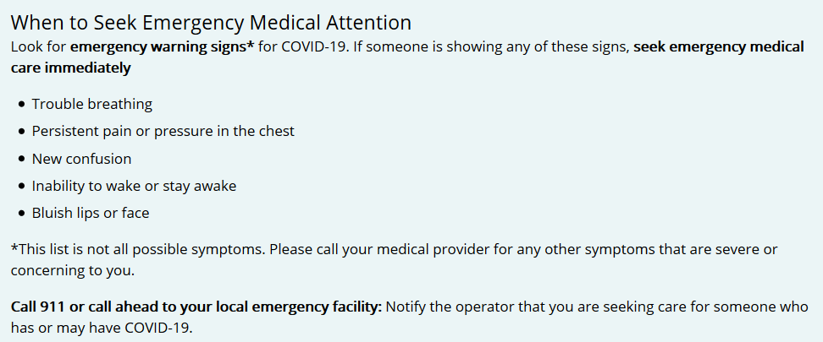

Follow these steps during/after home visits
- Before entering anyone’s home, sanitize your hands.
- Keep as much space between you and the person as possible given the nature of the home visit.

- Masks may be worn by the employee and/or client. If a medical condition prevents an individual from wearing a mask, alternatives should be discussed with the supervisor.

- If you cough or sneeze, do so into your sleeve.
- Home visits may take place outdoors.
- Immediately after leaving someone’s home, use hand sanitizer or wipes to sanitize.

Tips for Home Visits
As Requested:
- Educate clients on what the virus is and how to minimize exposure
- Educate clients and keep up to date on local orders related to the virus
- Leave written flyers and materials when necessary
- Engage in safety planning: does the client know who to call and what to do if they are not feeling well?
Recommendations for PPE home visit supplies:
- Hand sanitizer
- Clorox/cleaning wipes OR disinfectant spray/paper towels. Good for washing your hands, opening doors to apartment buildings, wiping down your steering wheel frequently, wiping down your phone, etc.
- Garbage bags (plastic grocery bags are perfect for this) to dispose of dirty gloves/tissues/wipes
- Disposable gloves
- Masks

*Programs may have more specific/restrictive guidance based on the unique nature of the home visiting program. The above represents minimum requirements for all programs

ADDITIONAL HEAD START COVID-19 MITIGATION CONSIDERATIONS
Community Levels
- Staff will have access to information on community COVID-19 levels and will have the ability to share with families. The link to community level information can be found here: https://www.cdc.gov/coronavirus/2019-ncov/your-health/covid-by-county.html
- With this knowledge, staff and families will make informed decisions on individual precautions.
COVID-19 Vaccination
- NMCAA will provide COVID-19 vaccination information to staff and families upon request.

Responsive to Changing Conditions
- Programs will follow the recommendations of Licensing and the local health departments regarding classroom closures due to COVID-19.
- Should a classroom closure need to occur, staff will follow the Center Based Temporary Closure Policy.
- Should recommendations include a pause in home based services, the COVID-19 Early Head Start Home Visiting Protocol will be followed for home based programming.
Communication Plan
- In case of classroom exposure to COVID-19, staff will notify parents through the NMCAA Child and Family Development Programs Health Notice, which can be found here: https://www.nmcaahs.com/communicable-diseases.html
- If notification of a community mandate is received, the NMCAA Mini Management team will meet as soon as is practicable to discuss next steps and to create a plan of communication for staff and families.
Additional Precautions
- Regular classroom and socialization area cleaning and disinfecting policies will continue to be followed. These can be found under Site Health Forms, at the following link: https://www.nmcaahs.com/health-forms.html
- NMCAA will individualize services for children of all abilities based on information from their health provider and/or family.
Further Resource Links
- Managing Communicable Diseases in Schools
managing_cd_in_schools_2022.pdf (nmcaahs.com)

- Coronavirus Vaccination and Mitigation Resources
https://eclkc.ohs.acf.hhs.gov/about-us/coronavirus/coronavirus

February 23, 2023

