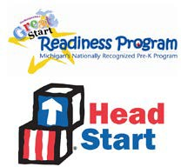
COMPLETION MEMO

CHILD’S NAME _______________________ PARENT’S NAME____________________________

PROGRAM

In order to complete your child’s application for Early Head Start/Head Start/GSRP consideration, we must have the following documentation. Without this information your child cannot be placed on a prioritized waiting list and will not be considered for placement in a classroom.
For your convenience this may be:

Mailed to:

Faxed to:

Text Images to:

E-mail to:

Dropped off at:

Child’s Official Immunization Record/Waiver if immunizations are not complete at time of application.
____

Proof of Income for the last 12 months, check all that apply.
____

- 2022 Federal Tax Return, W-2's, or Last 4 weeks of current paycheck stub’s | - Child Support Documentation  *For all children in the home
- MDHHS Cash Assistance (FIP), SNAP | - Third Party Document
- Disability, Social Security or SSI | - Unemployment
- College Grants and Scholarships | - Foster Care Stipend and/or Documentation

Copy of Child’s Birth Certificate or proof of age.
____

Other Information:
____

To be completed and sent with family after recruitment appointment for any missing documents.

3/2023 EHS-HS Team\Admin\Procedure Manual\ERSEA\Completion Memo

