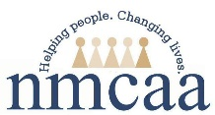
Procedures for Data Entry Child Plus
and Entry Express
HSPPS 1302.52 (a-d) Family partnership services
Family Services, Events Tab
- Click Services on the far left; select the child from the list of participants below or search for the child by name or birthdate using the search bar.
- Click Family Services (third from the left)
- Click Events on the left
*Shortcut for designating Case Worker - Click Family Services Information tab; go to the drop down list of names. Begin typing Case Worker last name and click enter when correct name appears OR click scroll down arrow for list of names and click enter. Click “Save” when finished
Thereafter, the correct name will automatically populate each time you “Add Event & ADD Action.”
Dual Enrolled families: Enrolled in EHS and HS, EHS will initiate/complete the Family Partnership Agreement and Family Outcomes Tool in Child Plus & provide copies to Head Start Teacher for supporting the family & for the child file.
Adding an Event:
You will “Add Event” in the Family Services section of Child Plus for the following:
- Home Visits – Documenting home visits (For FES)
- Need Identified – The family has a need requiring support through direct service or referral.
  - Direct Services
  - Referrals (Includes CPS referrals made by staff)
  - School Readiness Goal The family is establishing School Readiness Goals (Child Development). Support of a referral or direct service may not apply.
  - Communication which needs documenting such as
    - CPS involvement (Staff made a CPS referral; OR staff did not make a referral, but CPS called and/or observed at school for information or to give information).
    - Chronic absenteeism (Follow up within Attendance Tab; See ChildPlus Direct Entry Attendance Follow Up - FES Instructions)
- Family Partnership Agreement Goal Process- The family is establishing FPA goals.

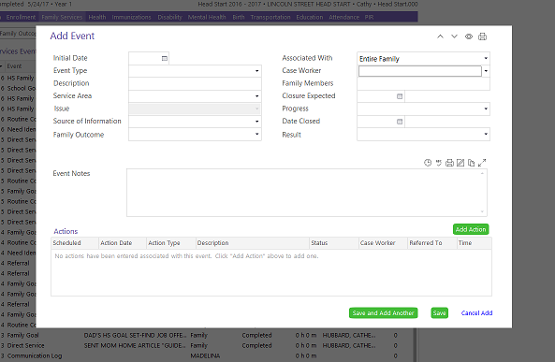
- Home visit Complete (FES)
- Click Add Event
- Initial Date: when home visit took place
- Event Type: Enter Home Visit
- Description: Enter Home Visit Completed
- Service Area: Social Service
- Issue: Leave blank
- Source of Information: Leave blank
- Family Outcome: These are the areas of the HS Parent Family and Community Engagement Framework. Choose only 1 that applies. [1302.52 (b)]
- Associated With: This will be auto-filled
- Case Worker: Drop down list of names* Begin typing your last name & click when your name appears.
- Family Members: Leave blank
- Closure Expected: Leave blank
- Progress: Click Completed (Date completed)
- Date Closed: Date Completed
- Result: leave blank
Action Notes: Use time stamp each time an entry is made. This area can be used to provide additional detail about identified need. Click “Save” when finished

Home Visit Missed (HVM)
Chronic cancelling or nobody home. Takes place after 2nd HV missed or Cancelled.
- Add Event
- Initial Date: When home visit was scheduled.
- Event Type: Click Home Visit
- Description: Enter Home Visit Missed OR HVM
- Service Area: Social Services
- Issue: Leave blank
- Source of Information: Leave blank
- Family Outcome: These are the areas of the HS Parent Family and Community Engagement Framework. Choose only 1 that applies. [1302.52 (b)]
- Associated With: Leave blank
- Case Worker: Drop down list of names* Begin typing your last name & click when your name appears.
- Family Members: Leave blank
- Closure Expected: Leave blank
- Progress: Click Cancelled
- Date Closed: Date Cancelled
- Result: leave blank
Action Notes: Use time stamp each time an entry is made. Use this to provide additional details about HVM. Ex. - Original dates should be identified for when hv was scheduled with description; mom called to cancel on ______ (date) because ____________.
Click “Save” when finished
- Need Identified (Family has a Need Identified that requiring support through Direct Service OR Referral). School Readiness Goals may not require a Direct Service or a Referral.

There are 3 different and separate event types for Need Identified
- Family Goal
- Home Visit
- Need Identified, which includes:
  - Direct Services
  - Referrals (Includes CPS referrals made by staff)
  - School Readiness Goal
  - Communication which needs documenting such as
    - CPS involvement (Staff made a CPS referral; OR staff did not make a referral, but CPS called and/or observed at school for information or to give information).
  - chronic absenteeism (Follow up within Attendance Tab; See ChildPlus Direct Entry Attendance Follow Up - FES Instructions)

The first time you enter Need Identified:
- Add Event first
- ADD Action second
Direct Service:
Staff provided a Direct Service (To meet Need Identified; Examples: a requested handout or children’s social story or social emotional book related to a topic; A one-to-one “mini training,” which needs to be added to PIR fields of Need Identified & Parenting Education) Other examples - budgeting, cooking, positive guidance, child development, etc; OR parenting support from (Your Journey Together parenting curriculum), Conscious Discipline or parenting guidance that is “individualized” for situation (not the same handout provided to all families).
- Click Add Event
- Initial Date: Date of Need Identified
- Event Type: Enter Need Identified
- Description: Enter description of need.
- Service Area: Social Services
- Issue: Choose appropriate within scroll down menu
- Source of Information: Choose appropriate within scroll down menu
- Family Outcome: These are the areas of the HS Parent Family and Community Engagement Framework. Choose only 1 that applies. [1302.52 (b)]
- Associated With: This will be auto-filled
- Case Worker: Drop down list of names* Begin typing your last name & click when your name appears.
- Family Members: Leave blank
- Closure Expected: Leave blank
- Progress: In Progress, Cancelled or Completed (Date completed)
- Cancelled is only by the family if they no longer want the goal
- Complete is when family goal is complete
- In Progress (Staff will progressively follow up on goal with the family)
- Date Closed: Date Completed
- Result: Leave blank
Action Notes: Use time stamp each time an entry is made. This area can be used to provide additional detail about identified need. Click “Save” when finished

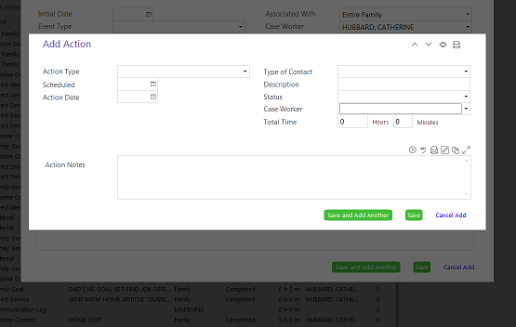
Click Add Action:
- Action Type: Scroll down arrow (Direct)
- Scheduled: Leave Blank
- Action Date: Date of Direct Service
- Type of Contact: Scroll down arrow (Choose type of contact that applies)
- Description: Describe the Direct Service
- Status: Scroll down arrow (Referral is Action Completed, Family Cancelled or Ongoing)
- Action Completed is when referral service need is met. Mental Health Referrals are completed only when the mental health sessions are completed
- Family Cancelled is only when family no longer wants Referral OR family is ineligible OR service is no longer available
- Case Worker: Begin typing last name & click enter when correct name appears OR click drop down list
- Total Time: leave blank
Action Notes: Timestamp entries. Use this area as a running log to provide any additional details and/or ongoing information related to the status of a referral. Click “Save” when finished
For accurate Reports & keeping PIR up to date, staff must do the following when providing a Direct Service of (giving a “mini training”)
- Go to Family Services Information tab
- Scroll down to area of Needs we refer families for
- Go to Need Identified box & click yes
- If Direct Service “mini training” is complete:
  - Go to appropriate Services Received boxes & click yes

Referral:
A referral is being made to meet Need Identified
Click Add Event
- Click Add Event
- Initial Date: Date of Need Identified
- Event Type: Enter Need Identified
- Description: Enter description of need.
- Service Area: Social Services
- Issue: Choose appropriate within scroll down menu
- Source of Information: Choose appropriate within scroll down menu
- Family Outcome: These are the areas of the HS Parent Family and Community Engagement Framework. Choose only 1 that applies. [1302.52 (b)]
- Associated With: This will be auto-filled
- Case Worker: Drop down list of names* Begin typing your last name & click when your name appears.
- Family Members: Leave blank
- Closure Expected: Leave blank
- Progress: In Progress, Cancelled or Completed (Date completed)
- Cancelled is only by the family if they no longer want the goal
- Complete is when family goal is complete
- In Progress (Staff will progressively follow up on goal with the family)
- Date Closed: Date Completed
- Result: leave blank
Action Notes: Use time stamp each time an entry is made. This area can be used to provide additional detail about identified need. Click “Save” when finished
Click Add Action
- Action Type: Scroll down arrow (Referral)
- Scheduled: Leave Blank
- Action Date: Date of Referral
- Type of Contact: Scroll down arrow (Choose type of contact that applies)
- Description: Where the Referral is made to (Keep each referral as separate Add Actions; Ex – Heat Assistance to DHHS and NMCAA would be separate Add Actions)
- Status: Scroll down arrow (Referral is Action Completed, Family Cancelled or Ongoing)
- Action Completed is when referral service need is met. Mental Health Referrals are completed only when the mental health sessions are completed
- Family Cancelled is only when family no longer wants Referral OR family is ineligible OR service is no longer available
- Case Worker: Begin typing last name & click enter when correct name appears OR click drop down list
- Total Time: leave blank
Action Notes: Timestamp entries. Use this area as a running log to provide any additional details and/or ongoing information related to the status of a referral. Click “Save” when finished
Referral Follow Up
Same process for School Readiness Goal & Family Goal Follow Up
Staff must follow up on Referral within 30-45 days Immediate needs should be followed up asap
- Go to original event entered & open
Click Add Action
- Action Type: Scroll down arrow (Follow Up)
- Scheduled: If you know date of appointment, you can enter it
- Action Date: Follow Up date
- Type of Contact: Scroll down arrow (Choose type of contact you had for Follow Up)
- Description: Describe the outcome of Follow Up
- Status: Scroll down arrow (Referral is Action Completed, Family Cancelled or Ongoing)
- Action Completed is when referral service need is met. Mental Health Referrals are completed only when the mental health sessions are completed
- Family Cancelled is only when family no longer wants Referral OR family is ineligible OR service is no longer available
- Ongoing Is until there is an outcome of either Action Completed or Cancelled
- Case Worker: Begin typing last name & click enter when correct name appears OR click drop down list
- Total Time: leave blank
Action Notes: Timestamp entries. Use this area as a running log to provide any additional details and/or ongoing information related to the status of a referral. Click “Save” when finished
When Referral is Completed or Cancelled:
- Go to original Event entry, and change from In Progress to Completed or Cancelled.
- Date Closed: Enter date Completed or Cancelled

For accurate Reports & keeping PIR up to date, staff must do the following when making Referrals:
- Scroll down to area of Needs we refer families for
- Go to Need Identified box & click yes
- If Referral is complete:
  - Go to Services Received box & click yes

School Readiness Goal The family is establishing School Readiness Goals (Child Development). School Readiness Goal follow up occurs at home visits, PTC, and if appropriate during phone or center contacts. Add Action. (See above Referral Follow Up instructions, because it’s the same Add Action process.) Referral or Direct Service may not apply to School Readiness Goal; If it does apply, then follow the Referral Add Action process.
- Click Add Event
- Initial Date: Date of Need Identified
- Event Type: Enter Need Identified
- Description: Enter description of School Readiness Goal(s)
- Service Area: Social Services
- Issue: Child Development (Child goal)
- Source of Information: Choose appropriate within scroll down menu
- Family Outcome: These are the areas of the HS Parent Family and Community Engagement Framework. Choose only 1 that applies. [1302.52 (b)]
- Associated With: This will be auto-filled
- Case Worker: Drop down list of names* Begin typing your last name & click when your name appears.
- Family Members: Leave blank
- Closure Expected: Leave blank
- Progress: In Progress, Cancelled or Completed (Date completed)
- In Progress (Staff will progressively follow up on goal with the family)
- Complete is when family goal is complete
- Cancelled is only by the family if they no longer want the goal
- Date Closed: Date when school readiness goal is accomplished or in cancelled
- Result: Leave blank

Action Notes: Timestamp entries. Use this area as a running log to provide any additional details and/or ongoing information related to the status of a referral. Click “Save” when finished
When School Readiness Goal is Completed or Cancelled:
- Go to original Event entry, and change from In Progress to Completed or Cancelled.
- Date Closed: Enter date Completed or Cancelled

Communication which needs documenting:
- CPS involvement (Staff made a CPS referral; OR Staff did not make a referral, but CPS called and/or observed at school for information or to give information).

- Click Add Event
- Initial Date: Date of Need Identified
- Event Type: Enter Need Identified
- Description: Enter description of communication topic
- Service Area: Social Services
- Issue: Choose most appropriate topic
- Source of Information: Choose appropriate from scroll down menu
- Family Outcome: These are the areas of the HS Parent Family and Community Engagement Framework. Choose only 1 that applies. [1302.52 (b)]
- Associated With: This will be auto-filled
- Case Worker: Drop down list of names* Begin typing your last name & click when your name appears.
- Family Members: Leave blank
- Closure Expected: Leave blank
- Progress: In Progress, Cancelled or Completed (Date completed); Mostly this filed will either be In Progress or Complete
- In Progress (Staff will progressively follow up on goal with the family)
- Complete is when family goal is complete
- Cancelled is only by the family if they no longer want the goal
- Date Closed: Date of communication or CPS called or CPS observed
- Result: Leave blank
Action Notes: Use time stamp each time an entry is made. This area can be used to provide additional detail about identified need. Click “Save” when finished
Chronic Absenteeism also needs documenting:
- Either select child from your Attendance Dashboard or via the Attendance tab
- Click on Add Follow Up
- Select Due Date
- Choose the kind of follow up:
- Attendance Plan
- Follow Up Required
- Multiple Absences
- Multiple Tardies
- Percentage of Attendance
- Enter the responsible staff person’s name for the specified attendance follow up.
- Enter whether or not the follow up has been completed.

- Within the Notes section, tell the story of what happened.
- An example for the Notes section would be to document that a home visit occurred and what was addressed.
- Another example for the Notes section might be to include what a family shares regarding a barrier to attending regularly and any plans created to address the barrier. If follow up to the barrier is tracked in Family Services tab, note “See Family Services tab”Save when finished
Step 1
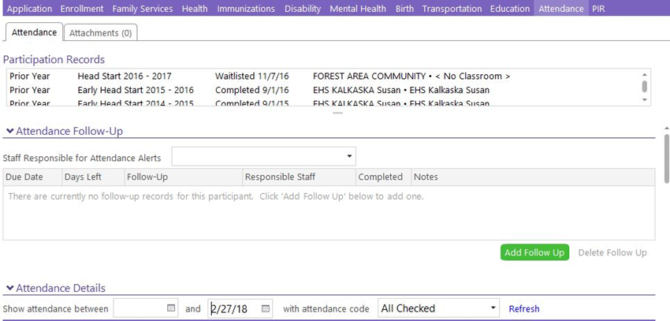
Step 3-7
Step 2

3) Family Partnership Agreement. [1302.52(a)]
This where we show details about the Family Partnership Agreement (FPA).
Actions, such as Direct Service or Referrals, related to the FPA will be recorded in the “Add Action” section.
- Add Event first as Family Goal
- Initial Date: Date goal was set OR parent declined to set a goal.
- Event Type: Family Goal
- Description: Write description of goal
- Service Area: Social Service
- Issue: Drop down menu for appropriate choice
- Source of Information: Choose appropriate from scroll down menu
- Family Outcome: These are the areas of the HS Parent Family and Community Engagement Framework. Choose only 1 that applies. [1302.52 (b)]
- Associated With: This will be auto-filled
- Case Worker: Begin typing your last name & click when name appears, OR click drop down menu for names.
- Family Members: Leave blank
- Closure Expected: end of school year date.
- Progress: In Progress, Complete (Date completed) or Cancelled
- In Progress (Staff will progressively follow up on goal with the family)
- Complete is when family goal is complete
- Cancelled is only by the family if they no longer want the goal
- Date Closed: Date Completed or Cancelled
- Result: leave blank

Action Notes: Timestamp entries. Use this area as a running log to provide any additional details and/or ongoing information related to the status of a referral. Click “Save” when finished
When Family Goal is Completed or Cancelled:
- Go to original Event entry and change from In Progress to Completed or Cancelled.
- Date Closed: Enter date Completed or Cancelled

Completing the Family Outcome Tool Needs Assessment
- Go to Family Services
- Click Family Outcomes (Completed once)
- Click Change who appears on list (bottom left) and Select Program Year – HS or EHS 2020-21 so your list populates.
- Enter Results – select yes or no
- Click Save when you are finished.

AFTER FOT is completed: Go to Family Services Information Tab
For Accurate Reports & keeping PIR up to date, do the following direct entry:
Needs Assessment
- Once FOT is completed - Click yes for completed within the Family Services Tab
- Click the date
- Valid until – End of school year
Needs Assessment Results
- Needs Services – Click yes if services needed are identified from completing the FOT
- Received Agency Social Services – Click yes if nmcaa services were received as a result of completing the FOT
- Additional Community Services Needed – Click yes if family/staff identify services needed as a result of completing the FOT
- Referred to Another Agency – Click yes if staff refers family to another agency for identified services needed as a result of completing the FOT

Home Practices and Routines
- Go to Family Services
- Click Family Outcomes Instrument (Family Outcomes Instrument is the Home Practices and Routines because it gives us “pre” and “post” data for time in our program).
- Make sure “EHS/HS 2020-21 School Year” is populated in the drop down box
- Click Home Practices and Routines – Determine the Assessment Period – “First” or “Second” – See the FOT and HP Guidance for further support.
- Click “Enter Results” under the appropriate assessment period
- Enter the date the assessment was completed next to “Assessment Completed”
- “Case Worker” Select the name of the person who reviews with the family
- Enter Results – see scoring legend – Lower Score means greater need. 5 = 7 days per week; 4 = 5-6 days per week; 3 = 3-4 days per week; 2 = 1-2 days per week
- For Confidence Level Scoring – Note that the drop down options differ from the response options. Select the number that corresponds to the response provided. Example – 5 = Calm

Family Partnership Agreement

  - In Family Goal Setting Process - Click yes, if the relationship building process with the family has begun after a home visit, even if a goal is not yet set.
  - Family Partnership Agreement - Click yes if a Family Partnership Agreement Goal is set.
  - Effective Dates – first box is for when a goal is set. “to” box End of school year date
  - Family Partnership Notes - Add if relevant
Child Plus – Entry Express Family Services Event
How to Enter a flier or resource shared with multiple families at one time.
Go to Entry Express
Select: Family Services Event
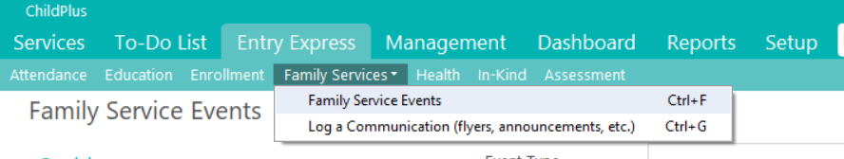

Select Which Participants to Include
Complete these fields:
Program Term: Enter program term
Sites: Select the sites you want to include
Classroom: Select the classroom for the sites you selected
Status: Select Enrolled
Classrooms: Put a check mark next to the classrooms you want to include
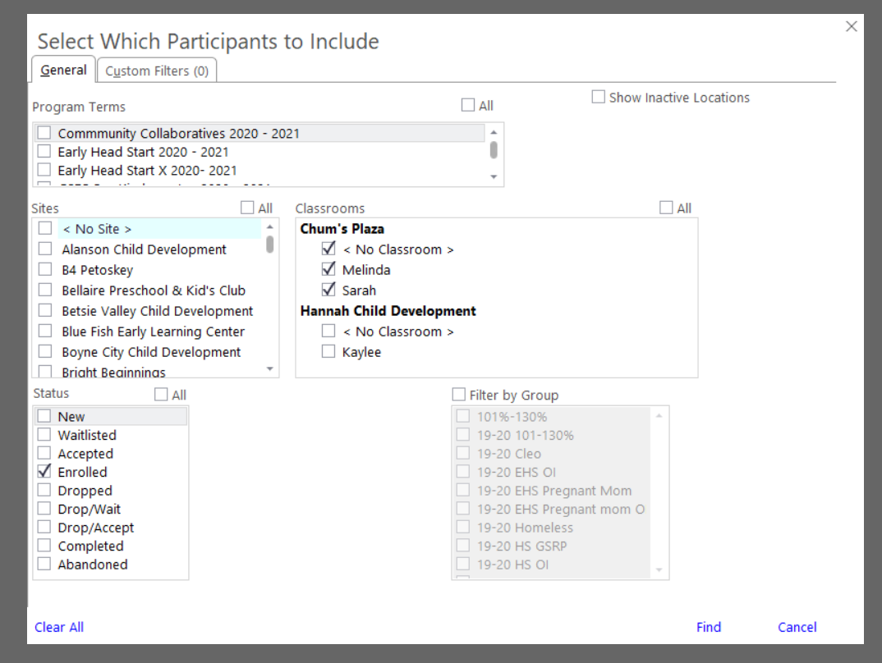
Click Find at the Bottom of the Screen

Enter Family Service Event Details
First, you will want to select the children you want to enter information for.
You do not have to enter the event information for all children in the class list. If you want to enter the event for all children they will already have a check mark by their name when you get to this screen, If you click the box that says “uncheck al”, you will be able to clear all check marks and then only put a check next to the children whom you wish to enter the event for.
Then, Complete these fields:
Initial Date: Enter Date information was sent
Event Type: PFCE Resources (We were formerly calling this Need Identified)
Description: Cov19 AND a brief description of what information was shared
Service Area: Select appropriate service area
Issue: Select appropriate issue
Source of Information: Select source of information
Family Outcome: Select Family Outcome
Case Worker: Select Case Worker
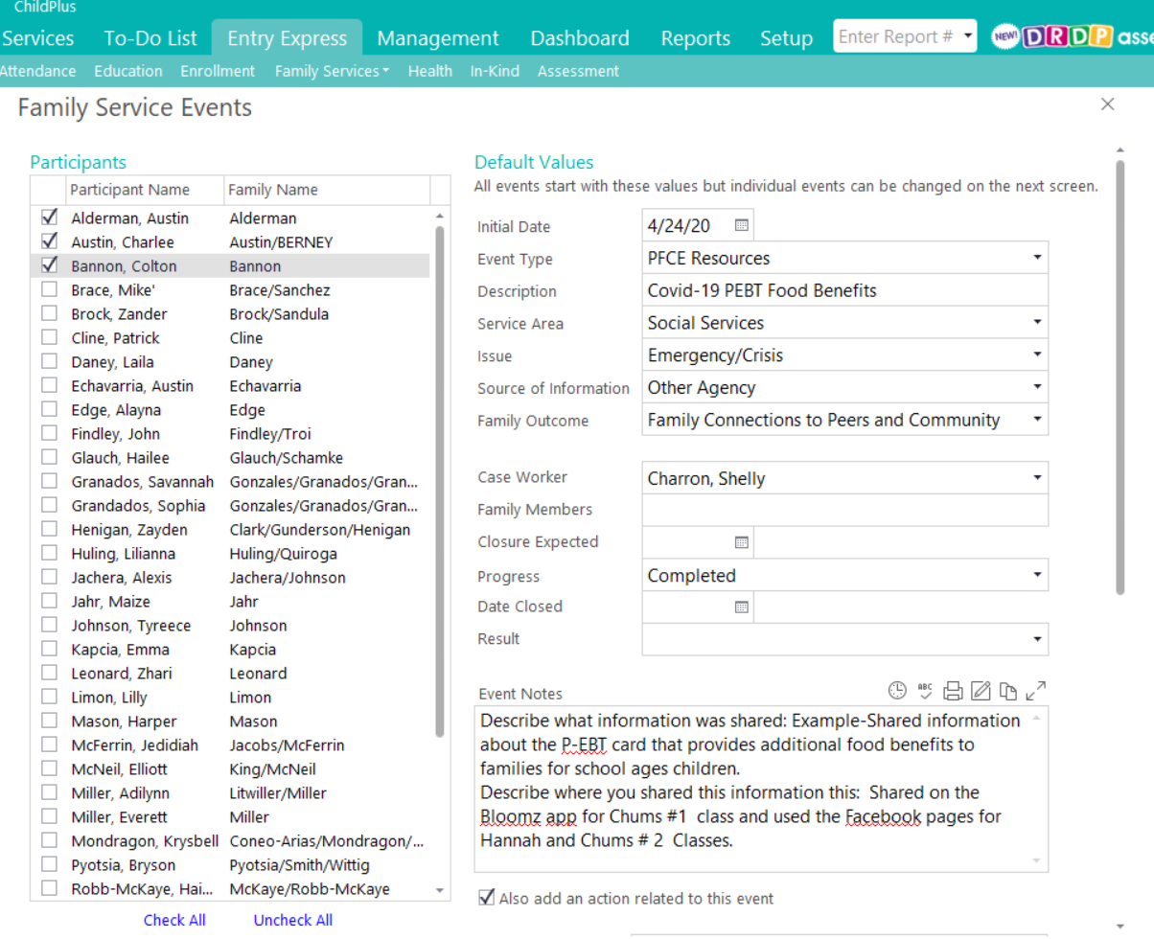

Participant
Names

To Add and Action to this Event:
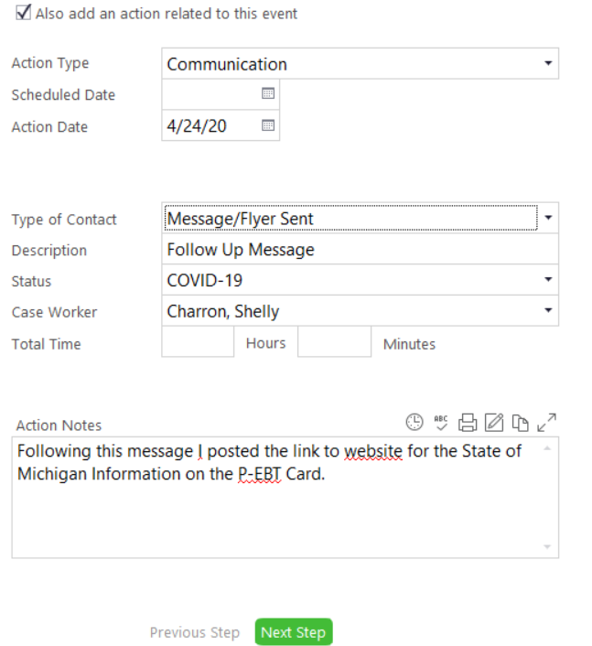
Click box that says Also Add an Action to this Event

Complete these fields:
Action Type: Choose action type
Action Date: Enter action date
Type of Contact: Choose type of communication
Description: Describe event
Status: Choose COVID-19 as the status
Case Worker: Enter case worker who did this action

Click on Next Step at the bottom of the screen

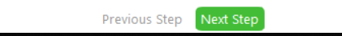

Edit Events for Individual Participants as Necessary
At this point you can change information for individual participants if you wish to enter something different for a specific participant. You will need to highlight the participant on the list of participants you selected.
To do this, click on the participant you want to edit, and they will show up as highlighted in gray.
You can change the event information in the fields to the right. You can edit as many individuals as you wish to edit individually. If you choose to edit another participant after entering the details of the first participant, you will just need to click on and highlight the next participant you wish to edit details for. The fields will automatically be saved with the new data you entered.

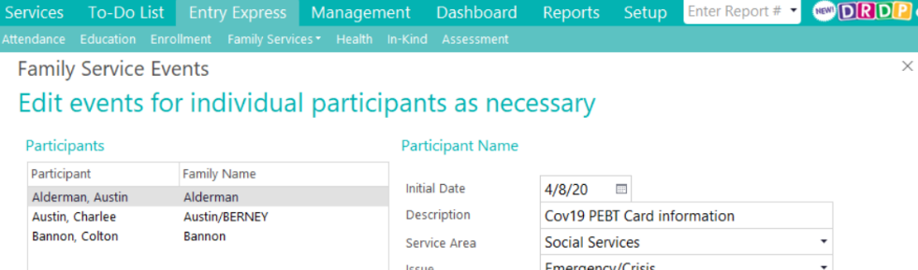

Click on Create Family Service Events at the bottom of the screen

