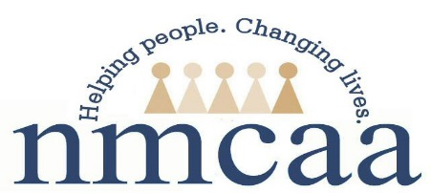

Child and Family Development Reactivation Form 2023
Return to Work Verification

Please Complete the Following:

SSN: _______-_____-_______ (Entire Number)

First Name: _____________________________

Last Name: _____________________________

First Day Back to Work (regular schedule): ___/ ____/ 2023
Home Address: ___________________________________________________
City: ______________________________________________________
Zip Code: ____________________

All the above information is required to report to the State of Michigan for your employment status.

Employee Signature: ___________________________________________________
Date: ____/____/ 2023

This form is to be sent immediately upon completion to:
Julie McNally, Human Resources Administrative Specialist

5/9/2023
EHS-HS Team\APOT\APOT Documents\2023-2024 APOT Documents\Child and family Development Reactivation Form

