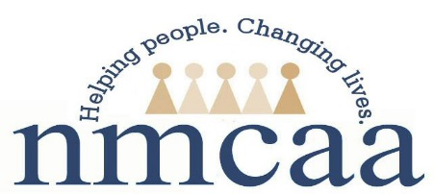

Child and Family Development Reactivation Form 2021
Return to Work Verification

Please Complete the Following:

SSN: _______ _____ _______ (Entire Number)
First Name: _____________________________
Last Name: _____________________________

First Day Back to Work (regular schedule): ___/ ____/ 2021
Address: ___________________________________________________
City: ______________________________________________________
Zip Code: ____________________
*** Regular schedule is your first regularly scheduled day back to work. This does not include time worked due to trainings, etc. prior to your regularly scheduled return date.
All of the above information is required to report to the State of Michigan for your employment Status.

Employee Signature: ___________________________________________________
Date: ____/____/ 2021

This form must be sent immediately upon completion to:
Julie McNally, Human Resources Administrative Specialist

5/2021
P:\Head Start\APOT\APOT Documents\2021-2022 APOT Documents\Child and Family Development Reactivation Form

