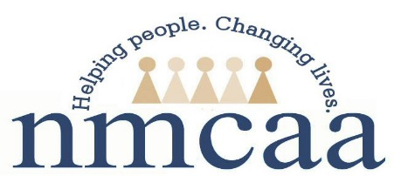

Child and Family Development Reactivation Form 2020
Return to Work Verification

Please Complete the Following:

SSN: _______ _____ _______ (Entire Number)
First Name: _____________________________
Last Name: _____________________________

First Day Back to Work (regular schedule): ___/ ____/ 2020
Address: ___________________________________________________
City: ______________________________________________________
Zip Code: ____________________

All of the above information is required to report to the State of Michigan for your employment Status.

Employee Signature: ___________________________________________________
Date: ____/____/ 2020

This form is to be sent immediately upon completion to:
Julie McNally, Human Resources Administrative Specialist

5/20
P:\Head Start\APOT\APOT Documents\2020-2021 APOT Documents\Child and family Development Reactivation Form

