iPad USAGE,
Attendance and Absence Codes, Meal Counts, Sign In/Sign out Instructions
Policy:
Licensing Rule R 400.8143 Children’s Records (10) The center shall maintain an accurate record of daily attendance at the center that includes each child’s first and last name, and each child’s arrival and departure time. HS 1302.16 Attendance (a) A program must track attendance for each child. CACFP 7CFR 226.15 (e) (4) Records and Record Keeping Meal attendance was taken at point of service/Meal attendance records are available and current/Center attendance records are maintained. CACFP 7CFR 226.15 (e) (5) Records and Record
Keeping A daily count is maintained for all meals served to adults who work in the program.
Procedure:
Preferred method: Use the ChildPlus iPad attendance app to record daily attendance, meal participation as well as sign-in and sign-out.
Alternate method if there are iPad or internet issues: The “Daily Attendance and Meals Worksheet” and the “Daily Attendance Sign-In / Sign-out Worksheet” will be sent via email at the beginning of the school year weekly (monthly later on). Print and use the most up to date version of paper forms to eliminate confusion. Shred unused, outdated attendance forms.
Parent Sign-In and Sign-Out: Parent signatures are required for time-in and time-out for each child. Use the iPad; If there are issues with the iPad or internet, then use the “Daily Attendance Sign-In / Sign-out Worksheet”. If the parent did not sign, then staff may complete the paper forms. Record the time; who dropped off/picked up; and then initial. Write in “BUS” for bussed children with a recorded time for bus.
Notes:
- Any child present for any amount of time, even if only 2 minutes, is marked “P”.
- You may correct sign-in/sign-out times after the fact yourself on the iPad without sending any paperwork to Program Support; just keep paper copies on file in the classroom. If you need Program Support to correct or enter times, you must send ink-originals.
- If you click on the section of the iPad which looks like “ … “ , you can enter specific times manually rather than a check-mark
- Attendance Codes: from the dropdown selection menu choose: P= Present A= Absent
- Absence Reason Codes: In addition to the “A” code when absent, use the following codes to indicate the reason in the secondary dropdown menu selection:

1 | Sick | 4 | Over Slept | 7 | No one Home/No Contact | 10 | No Transportation
2 | Missed Bus | 5 | Dr./Dental Appt. | 8 | Forgot | 11 | Needs Family Services
3 | Out of Town | 6 | Funeral | 9 | Left Area | 12 | Other

Meals: MEAL ATTENDANCE MUST BE MARKED AT POINT OF SERVICE (POS). POS is when these three conditions occur: 1) food and milk are on the table 2) the child is seated at the table and 3) children have been offered the food. (Point of Service / POS)
If you need to use paper copies for recording the meal participation, use the following meal codes:
B= Breakfast L= Lunch S= Snack
Reminder: If a child does NOT eat, but the three POS conditions noted above are met, we can claim the meal.
It is not required that the milk be open.
Adult meal counts: Must be written each day for Breakfast and Lunch in “Non-Part CACFP” fields.
Half-days: If B, L and S are normally served, but the classroom serves B & S due to a half day, note this in
Classroom Notes as “half day-served snack instead of lunch”.
P:\Head Start\Education\ATTCODES
P:\Head Start\Admin\ Procedures Manual\Licensing\Attendance and Absence Codes
4/19 Page 1 of 2
GENERAL INFO FOR FORMS:

- Date the forms correctly!
- A Change of Status must be sent to Michelle Karns for children who drop from the program.
- Use “A” (absent) when a child’s name appears on the attendance sheet but has dropped.
- You may write in a new child’s name at the bottom of the forms.
- Indicate reason for center closure – snow day, power outage, etc.
- If you have iPad issues/internet issues, you must send ink-originals to Program Support to store in the files in office. Remember: always any meal-change – EVEN IF YOU FIX IT THERE –after POS, or if you cannot do the meal selection at all, must go to Program Support as the original ink-copy; also, sign-in/out times that you cannot enter or fix there.
- Attendance sheets/sign-ins can be used through the week even if a new month starts midway.
- Mail the original ink-copy (no photocopies, faxes or scans) attendance/meal-sheet or sign-in forms to NMCAA, Program Support, 3241 Racquet Club Dr. Ste. A, Traverse City 49684
GENERAL INFO FOR iPAD:
- Use the “Classroom Notes” section on the iPad/ChildPlus to record unusual or noteworthy classroom matters.
- Click on each child’s line to record child-specific info, see the picture below. (tip: if you click on the child’s name, it will take you out of the screen. Click on the “HS” on their line, to highlight that child, then enter “Attendance Notes”.) Below, notice how Amelia’s line is highlighted, then her child-specific info is entered in “Attendance Notes” at the bottom.
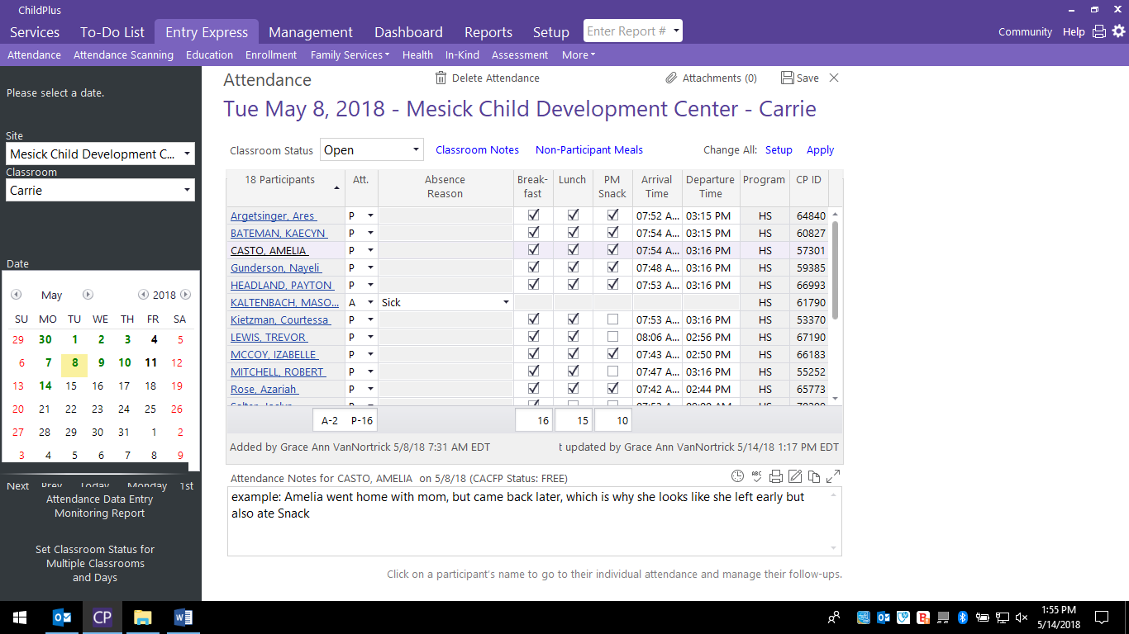

Questions? Call Sandy 231-346-2135
Reference: Licensing R 400.813 (10) Children’s Records,
HS 1302.16 Attendance (a) CACFP 7 CFR 226.15 (e) (5), 7 CFR 226.15 (e) (4) Records and Record Keeping
P:\Head Start\Education\ATTCODE P:\Head Start\Admin\Procedures Manual\Licensing\Attendance and Absence Codes
8/21 Page 2 of 2

