2022-2023 ANNUAL USDA/CACFP TRAINING FOR
HEAD START AND GSRP

ALL THINGS MENU!

In this section you will find:
- Food Fact Sheet
- NMCAA Approved Child Meal Pattern: Required Components and Minimum Serving Amounts
- CACFP and NMCAA Approved Cereals
- Menu Process
- Combination or Homemade Items
- Milk Notes and Fluid Milk Substitute Guidance
- Converting School Menus to Planned Menus
- Served Menu Checklist
- Record of Meals Purchased
- Communicating with School Food Vendors
- Meal Observations

It is a Head Start requirement that we participate in the Child and Adult Care Food Program (CACFP) and be in good standing.
The CACFP reimburses us for a portion of the cost of the meals we provide.
Most classrooms have all food delivered to them from a school vendor.
We currently have 4 sites that purchase their own food for at least one meal or snack. Mancelona, Charlevoix, Falmouth, and Marty Paul. At the end of this training, these four sites will be asked to remain, to review an additional section.
Everyone needs to know the information in this section!
This section includes information for sites that have a vendor for all meals/snacks and sites that buy their own groceries.
It is essential all classroom staff know this information so they can step in if the person primarily responsible is absent.
Staff need to be familiar with:
- What can and cannot be served
- Minimum serving amounts
- How and when to correctly complete a menu form
- Monthly items to be mailed to Program Support and the Business Office

How do I know what can be served?
NMCAA Preschools have various Child and Adult Care Food Program (CACFP), Head Start, and agency-specific guidelines and requirements for meals and snacks.
Some examples are:
Head Start regulations say we must provide a certain percentage of the daily nutrition needs for a preschool child. We include a meat/meat alt at breakfast to ensure the kids receive this.
It’s an NMCAA specification that we limit 100% juice to just once a week at snack time only.
Components required for each meal and snack
Breakfast Lunch Snack
At least 2 components from 2 different food groups.
EXAMPLES OF SNACKS THAT ARE NOT CREDITABLE:
Raisins and Apple Slices
Cheddar Cheese and Yogurt

Milk – skim, ½% or 1%
Meat/Meat Alternate
Fruit (or vegetable)
Grain
Milk – skim, ½% or 1%
Meat/Meat Alternate
Fruit (or vegetable)
Vegetable
Grain
(we can have 1 fruit/1veg, 2 veg, but not 2 fruit)
The next 3 guidance sheets will help you determine if all of our requirements are being met.
- Food Fact sheet
- NMCAA Preschools Approved Child Meal Pattern, Required Components and Minimum Amounts
- CACFP and NMCAA Approved Cereals

2022-2023
NMCAA PRESCHOOLS APPROVED CHILD MEAL PATTERN
REQUIRED COMPONENTS AND MINIMUM AMOUNTS

FOOD COMPONENT | BREAKFAST  4 Food Components  (milk, fruit, grain, protein) | LUNCH  5 Food Components  (milk, vegetable, fruit, protein, grain) | SNACK  2 Food Components. Only 1 May Be A Beverage
FLUID MILK Skim, ½%, 1% | 6 fluid ounces | 6 fluid ounces | 4 fluid ounces
PROTEIN (MEAT/MEAT ALTERNATE) CHOOSE:
Lean Meat, Poultry or Fish | 1 ½ ounces, or 7 grams  *Head Start Regulations require Protein at Breakfast | 1 ½ ounce or 10 grams | ½ ounce
Tofu, Soy Product or Alternate Protein Products | 1 ½ ounce | 1 ½ ounce or 10 grams | ½ ounce
Cheese | 1 ½ ounce | 1 ½ ounce | ½ ounce
Large Egg | ¾ of an egg | ¾ of an egg | ½ of an egg
Cooked Dry Beans or Peas | 3/8 cup | 3/8 cup | 1/8 cup
Peanut Butter or Soy Nut Butter or Other Nut or Seed Butters | 3 TBSP | 3 TBSP | 1 TBSP
Yogurt  no more than 23grams sugar per 6 ounces | 6 ounces or ¾ cup | 6 ounces or ¾ cup | 2 ounces or ¼ cup
FRUITS | ½ cup | ½ cup | ½ cup
JUICE | Not allowed | Not allowed | 100 % Juice once a week
VEGETABLES |  | ½ cup | ½ cup
Grains:
Must serve 1 Whole Grain Per Day:
Whole-grain rich or Enriched Bread | ½ oz eq | ½ oz eq | ½ oz eq
Whole-grain rich or Enriched Bread Product, (such as crackers, biscuit, roll or muffin) | ½ oz eq | ½ oz eq | ½ oz eq
Whole-grain rich, Enriched or Fortified Cooked Breakfast Cereal, Cereal Grain and/or Pasta | ½ oz eq | ½ oz eq | ½ oz eq
Whole grain-rich, Enriched or Fortified Ready-to-Eat Breakfast Cereal (dry –SEE APPROVED CEREAL LIST | ½ oz eq | ½ oz eq | ½ oz eq

CACFP and NMCAA Approved Cereals

- The approved cereals – below – are the only cereals that can be served.

- No granola bars or cereal bars or squares or breakfast bars, rounds or biscuits, etc are allowed as the grain component if the perception is that they are sweet.
(For instance, anything sugary, or that has chocolate or caramel)

Please note, Crispix cereal is no longer on our approved cereal list as it has increased to 13% sugar.

APPROVED READY-TO-EAT CEREALS
Cereal | % sugar | ½ oz eq
Asterisks indicate Whole Grain (WG)
Cheerios - Plain * | 4 | ½ cup
Corn Chex * | 10 | ¾ cup
Corn Flakes – Plain - Any Store Brand | 8 | ½ cup
Grape-Nuts Original * | 9 | 1/8 cup
Kix - Plain * | 10 | ¾ cup
Rice Chex * | 8 | ¾ cup
Rice Krispies - Gluten Free only | 4 | ¾ cup
APPROVED HOT CEREALS
Cereal | % Sugar
Any store brand: Plain instant oatmeal (packets) * | Approx. 2 | ¼ c cooked or 14 gr dry
Quaker Brand:  1-Minute Original (Plain) Oatmeal (in packets) * | 2 | ¼ c cooked or 14 gr dry
Old Fashioned or 1-Minute (in canister) *  Steel Cut Quick 3-Minute (in canister) * | 2 | ¼ c cooked or 14 gr dry
Cream of Wheat – Original (2 ½ Minute Box) | 0 | ¼ c cooked or 14 gr dry
Malt O’Meal Brand:  Original or Creamy Hot Wheat (in boxes) | 0 | ¼ c cooked or 14 gr dry

Menu Process – Beginning of the Year
- At the beginning of the year, if you have a parent corner in the hallway, post a note telling parents the menus are displayed in the classroom.
- Make a sign ‘MENUS’ in print large enough to be seen across the classroom and place this above where you will post the menus on a wall or cabinet, where it will be convenient to write on the menus.
- Your planned menus will become your served menus as you update them at each meal/snack with temperatures and any substitutions.
- If you have planned menus located in the hallway or parent corner, you must also update them with any substitutions, therefore our goal is to have only 1 set of menus when possible.
- Go to the kitchen and introduce yourself. Get a name and phone number for a kitchen staff person so you can call in case something is missing from the food that is delivered or picked up.

Name:_________________________
Phone Number:_________________

Please save your kitchen contact information in your phone, so you can notify them if your classroom will be closed. This will help prevent wasted food and food charges.

Menu process - Each Month
- I email Publisher menu forms to teachers at the beginning of the year. Save these menu forms to your computer. Either print the appropriate blank menu forms to fill in by hand or fill them in using your keyboard.
- They are also on Weebly as PDFs.
- From the kitchen, obtain the monthly menu for your site; or create one if buying groceries.
- On each menu form, fill in the site, teacher name, month, and the dates for each day.
- To be CACFP compliant we must transfer the meal information from the kitchen menu to our blank menu forms, listing components individually and specifically. Use the Served Menu Checklist to detail correctly. For vague items like fruit cup, fresh veggies, etc., I’m asking that you highlight those items as a reminder to fill in the specific item at that meal or snack time. If you purchase groceries for meals or snacks, use our resources to create your menus, using the served menu checklist to detail correctly.
- You have now created your planned menus.
- Email your planned menus to svanochten@nmcaa.net . I send these planned menus to our dietitian for review. She ensures all requirements are met.
I will email you the dietitian’s feedback. If you see a question like “What kind of cheese?” or “Is the sausage low fat?” you don’t need to respond but do be specific when you write the next planned menu. ‘Colby’ cheese instead of ‘cheese’. Turkey sausage instead of ‘sausage’.

- Attach your planned menu forms to the wall or cabinet – visible and handy to write on.
- Use blue ink to write in temps, substitutions, CN or HM, by the end of each meal or snack every day. Also Circle the type of milk that is served for breakfast and lunch and any snacks if applicable.
These menus are now your served menus.
- If you have additional planned menus posted, remember, they need to be updated with any substitutions at each meal.

Combination Items:
If a product with two components, such as a pizza (meat/meat alt and a grain) is served, it must be determined if it came that way from a factory (CN/Child Nutrition label), or if the vendor assembled it (HM/homemade). If it was put together at a factory, we must know if it meets the proper amounts of protein and grain. We will need a CN label.
CN Label (Child Nutrition Label) is the designation for a combination item that has been analyzed by USDA chosen labs to determine which components it satisfies. For instance, pizzas served by schools are often “heat and eat”. They will have a CN label. Combination menu items, such as: pizzas, breakfast burritos and tacos that are factory pre-assembled, must be noted on the menus as CN.
Example: Mozzarella cheese pizza (CN)
Meat/alt = Mozz cheese
Grain = pizza crust wg
Designating Home Made
If it is determined that the kitchen assembles a combination item such as pizza or breakfast burritos, note “HM” by the item on the menu.
Example: Burrito HM
Eggs and LF turkey sausage
Tortilla wg
Combination items can only credit towards 2 food components.

- Fill in the Record of Meals Purchased from Vendors for that day. Enter the # of meals/snacks received that day.
- At the end of the month, review the written on (served) menus for accuracy using the Served Menu Checklist. If menus are scribbled on or spilled on, we still need the originals that you wrote on. If really gross, put them in a Ziploc and send them.
- Place a copy of these menus in your file before mailing
- Put the served Menu Checklist with the served menus and US mail them to Program Support. Self-addressed stamped envelopes for this purpose were given to teachers at APOT. Each envelope has enough postage for 9 regular sheets of paper.
- Mail menus no later than the first week of the next month.
- Mail/email the Record of Meals Purchased from Vendors form to the Business Office now also.
- Repeat Process so that new menu forms are filled in and posted on the wall or cabinet in time for the first school day of the next month.

Notes about Milk
There must be enough milk for every child to have:
6 ounces per meal
4 ounces per snack, if served at snack
Make sure the milk is on the table with the other foods and available for each child. You do not have to open the carton if a child does not want it.

Water must be available to children, but it cannot be on the table in a pitcher at breakfast or lunch. Children who desire water at these two meals would generally get up and get it themselves.

Types of fluid milk substitutes and cow’s milk that require special consideration are:
soy milk coconut milk
cashew milk rice milk
almond milk 2% or whole milk
These require special consideration for Civil Rights and reimbursement. If a parent request any of these milk substitutes, call or email Sandy. I will help you through the process and share the appropriate forms that need to be completed and offer other help.
svanochten@nmcaa.net 231-346-2135

If a parent has a special food request of any kind, not just for milk, call or email Sandy.
This will ensure that we have the proper form filled out and on file here at Program Support.

Next are examples of transferring information from the school menus to our menu forms, the served menu checklist and the record of meals purchased forms
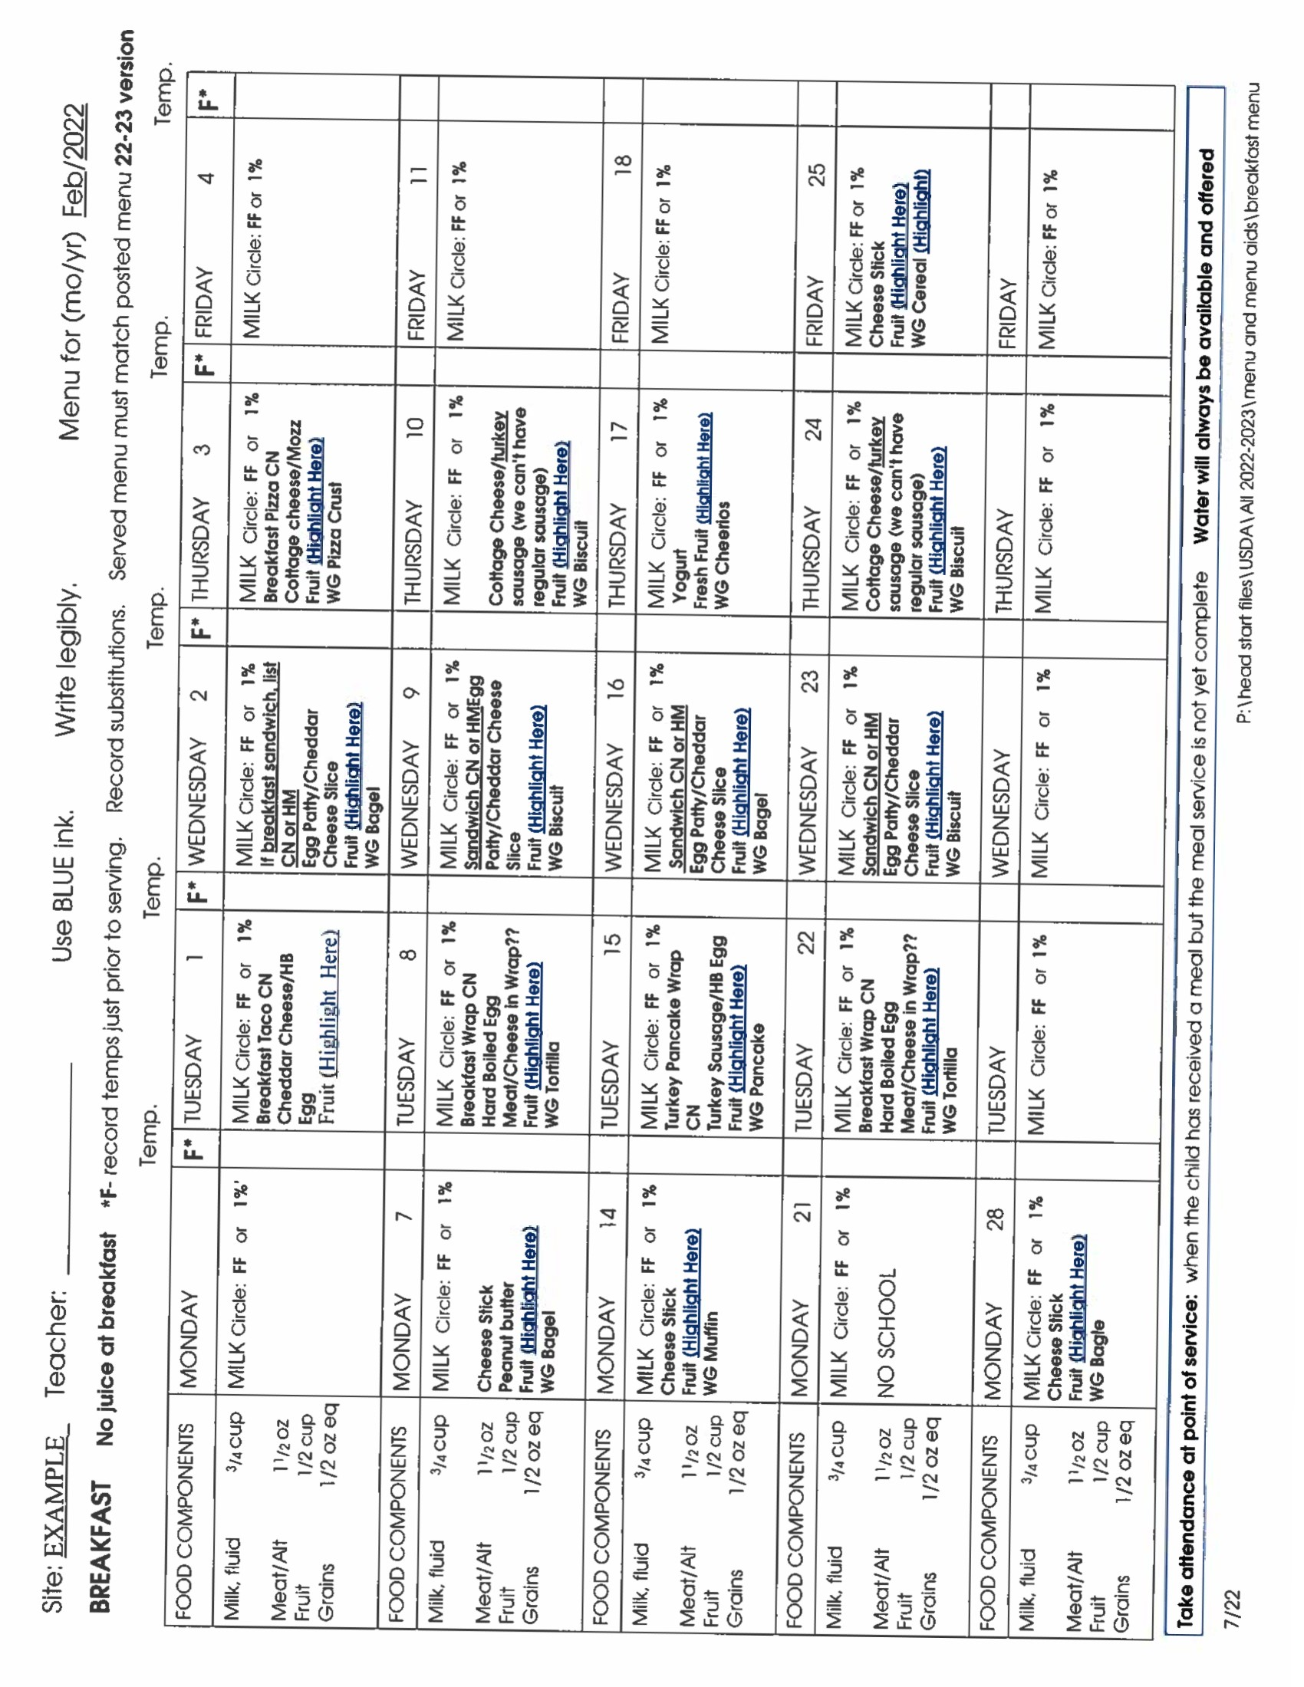

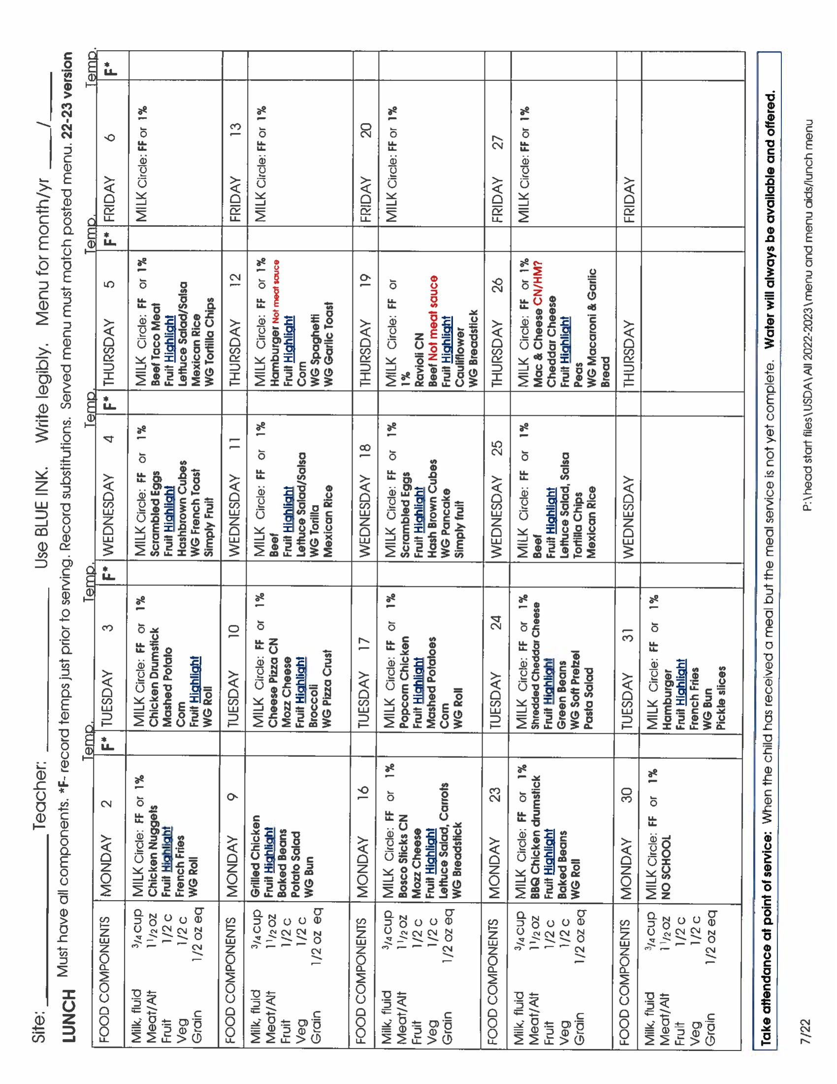

Served Menu Checklist
This checklist can be used anytime during the month but is completed at the end of the month to detail the entries on the served menu forms.
Assigned staff signs and dates the form and sends it along with the served menu forms to program support.
Using this checklist will help us receive a maximum reimbursement for our meals and snacks.
On the back/2nd page of the checklist are some examples of items we see commonly see noted wrong on menus. Some other issues that can cause us to lose reimbursement for a meal or snack are:
- No milk circled
- No whole grain (wg) indicated for the day.
- Missing components, menu says ‘fruit’ or ‘vegetable’.
  - The vendor may put that on their menu when they are unsure of what they will have on hand when for that meal. Update the menu, writing in the specific item, when the meal is served. Use a highlighter and highlight those ‘vague’ items.

SERVED MENU CHECKLIST
Served Menus are the menu forms on which temps and substitutions are recorded at mealtime

COMPLETE THIS FORM AND MAIL IN WITH THE SERVED MENUS
Site___________________ Person completing form ________________________ Menu month_________
□ Center, teacher and month are written on each menu form
□ Each menu box is dated with the day of the month
□ The correct menu form is used for Breakfast, Lunch and Snack
□ Milk type is circled for every breakfast and lunch, and any applicable snack
□ Temps noted by milk, and hot or cold items. [Cold= 41° and below; hot items= 135° and up; reheat to min. 165°]
□ Cereal is on the Approved Cereals List and named specifically; Cheerios (WG), Corn Chex, etc.
□ Is a Whole Grain noted accurately once a day? DO NOT MARK ALL GRAINS WG UNLESS THEY ARE! School vendors will note which grain items are Whole Grain on the menu they send you. (Rice Krispies and Corn Flakes are on our approved cereal list, but they are not WG).
□ (For centers purchasing) Need a minimum of one WG a day, all other grains must be at least enriched, even tortilla chips.
□ (For centers purchasing) Is the WG product on the Acceptable Whole Grain Choices list or been analyzed for WG by our dietitian?
□ Note grains using brand names: Ritz WG; Aunt Millie’s WG White; Cheerios WG; as much as possible; it’s ok if school vendor does not note brand names in grains in meals but do note the snack crackers.
□ If served a breaded item (chicken nuggets, for example), is another grain item served at that meal?
□ Pizza notes: Did you note ‘crust’ for grain component? Noted “HM” or “CN”? Type of cheese written in?
□ Are fruits named specifically? (Not just “fresh fruit” but “apples”) Exception: “mixed fruit”
□ Juice – noted as “100% (type) juice.” (Snack only, limit once a week)
□ Are vegetables named specifically? (Not just “veggie” but “corn”). Exception: “mixed vegetables”
□ If “Salad” is noted, must specify “lettuce salad”, “pasta salad” or “fruit salad”
□ Write “baked fries” instead of french fries
□ Cheeses are natural and specific (Ex. “cheddar cheese, Colby cheese, etc”) No American or processed cheese.
□ Meat – named specifically. “HM beef sloppy joe” or “turkey taco meat”
□ Are ALL meal components noted for each meal and snack? (use the left hand column on menus to be sure)
Breakfast – 4 components Lunch - 5 components Snack – at least 2 components SEE OTHER SIDE

MISC NOTES:
□ Potato is a vegetable
□ Cream cheese is NOT a meat/alt/protein – it’s all fat and so just an “extra”
□ Breading on chicken, fish etc doesn’t count as a grain in the – always need a separate grain, such as a roll
□ (For centers buying grains) General rule for counting a grain as Whole Grain: The front of the box must say 100% Whole Grain. If the box says “made with” whole grain, then it is probably not enough to qualify as WG. NEW! Use the list of Acceptable Whole Grain Choices for ease. If you’re not sure an item is whole grain (wording can be tricky), copy the nutrition and ingredients from the package and send to program support so the nutritionist can analyze it.

This form contains information on items we see commonly noted wrong on menus. Here is the correct way to document these items for your reference. |  | Juice can be served once a week at snack. Note like this:  100% apple Juice  (whatever type) |  | Vendor will note items on their menu that are Whole Grain.  Don’t guess! Mark as WG only items noted as such on the vendor menu, or on our resources. |  | MILK Circle: FF or 1%  Cheddar cheese  (cheese is specific)  Macaroni  Can’t write just ‘mac and cheese’ |  | For mac and cheese, pizza, etc, inquire from kitchen if home made (HM) or assembled in a factory (CN) or ask Sandy. Note result on menu by that item.
MILK Circle: FF or 1%  Mozz cheese (cheese is specific)  Pizza crust (WG)  Can’t write just “Cheese Pizza” |  | MILK Circle: FF or 1%  Beef Taco meat  (type of meat is  specified)  Tortillas  (grain is specified)) |  | MILK Circle: FF or 1%  Chicken nuggets  (An additional grain is noted since the breading does not count as such)  Dinner roll |  | MILK Circle: FF or 1%  Turkey sandwich  (Bread is noted; cannot be assumed)  Bread |  | MILK Circle: FF or 1%  Cheerios WG  (name of cereal is specific, not just “cereal” or “Approved cereal”)

Communicating with School Food Vendors
When food is delivered or picked up, verify that all components are there(as best you can without opening the insulated containers early).
If a component is missing, immediately contact the vendor and ask for the item.
We cannot claim a meal that is missing a component, nor can we pay the vendor.
Example: The classroom received milk, breaded chicken, peaches, tossed salad and ranch dressing.
The grain component is missing (We don’t count breading as a grain component).
Call the kitchen contact person for the grain component.
What to do if you experience a problem with meals:
- Be investigatory rather than accusatory if you think something is odd regarding meals
- Be sure to have viewed all the trainings re: USDA and especially the meal patterns so you have a basis for understanding
- Check to make sure you have all meal components before you leave the Kitchen/food service leaves.
- If something is missing – ask the vendor for it before you leave the kitchen/they leave. We need all components for each meal or snack to be partially reimbursed.
- If you think a component is missing but the food service says not: Don’t stew about it!
Instead: 1. Take a photo 2. Send to Sandy and 3. Follow up with a phone call to Sandy.
- Remember, like you, food service people are busy, work hard for their pay and are on a tight schedule and budget. When there is a situation that needs to change approach them with a kindly “we’re in this together attitude”
- If you’d like a script to follow in your quest for food peace:
  - Evoke partnership and goodwill - “I know we all have the children’s best interest at heart”
  - Describe the situation objectively, in a few words as possible, without judgmental words like ‘disgusting’ or ‘inedible’ - “Here’s our situation, when we receive peanut butter sandwiches with mashed bananas, the bananas turn black, and no one wants to eat them”
  - State the problem. “It’s a problem to us because both the children and adults are going hungry”
  - Ask for their input. “Do you have any ideas about what could help our situation?”
  - Accept reasonable fixes and thank them. “Ok. Maybe sliced apples will work. Let’s give it a try!” Thanks for working with us on this issue.”
  - Sandy is ready and willing if you would like help communicating with the food vendors.
  - Send Sandy photos if needed. A photo says 1,000 words!

Meal Observations
9- month classrooms receive two meal observations a year for USDA and Head Start Meal Reviews.
10- month classrooms receive 3 meal observations a year.
All observations are unannounced.
We arrive with a smile and a clipboard

At this time…… we are planning on meal observations being done in person this year.
Susan Duke-Tyler may be doing some meal observations.

We will be requesting Family Style meals from our vendors and children will be serving themselves.
We may however see more individual food items than we did before COVID, it will depend on the individual schools.
Each teacher/classroom is receiving this training in a binder. Please keep this binder readily available in the classroom for quick reference.
Included inside the binders are ‘attendance/sign paper originals’ envelopes and postage paid served menu envelopes.

