ACCESSING YOUR EMAIL ACCOUNT

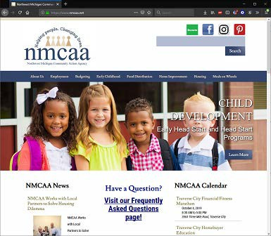
- Go to WWW.NMCAA.NET
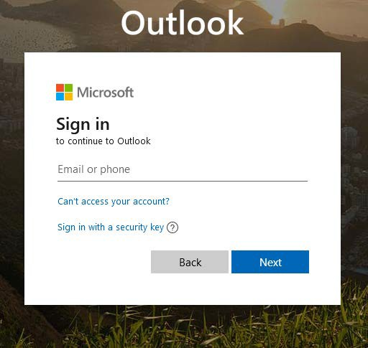
- Click on NMCAA MAIL at the bottom of the home page.
The Outlook Web App will appear.

- IN THE SIGN IN FIELD, YOU
WILL TYPE (first initial last name)@nmcaa.net

- DEFAULT PASSWORD IS:
first initial last initial 1234$$
For example, John Smith would enter:
EMAIL ADDRESS
jsmith@nmcaa.net
Password
js1234$$
(UNLESS YOU HAVE PREVIOUSLY CHANGED THE PASSWORD)
5. In rare instances, there will be some exceptions to the Username rules.

If you have any problems, please contact the IT department: IT@nmcaa.net or
1-800-632-7334.

Email Profile Picture Instructions

To apply a profile picture to your work email account, please refer to the following instructions:
- At the top of the page, click on your initials or profile picture.
If this is the first time accessing your email, you will see a colored circle with your initials at the top, right corner of the page.
- A new box will populate with your name, email, and links with other options. Click on the circle with your initials (or your existing profile picture).
- In the Change your photo dialog, select Upload a new photo.
Please be sure that this is an individual picture of yourself and professionally appropriate.
- Choose a photo to upload and select Apply.
Note: Your new photo will appear the next time you sign into Microsoft 365.

5/23 EHS-HS Team\Procedure Manual\Technology\NMCAA Email Instructions

